**1. INTRODUCTION**

The organic food chain ideal calls for a sustainable system modeled on nature that requires not only no synthetic chemicals but no purchased inputs of any kind, and that returns as much to the soil as it removes. For the rapid growth of the population, it must consider the proper use of the agriculture sector to fulfill our basic needs. It is possible to gain food security by boosting agricultural production. In any food factory or organization, it must ensure the food quality and nutritional issues that are a big factor for consumer’s health. The whole world is trying to gain food security for its rapidly growing population. In a secured food network system when someone buys food he must be aware of the food-producing method and must be informed about the raw materials of the food. One of the best ways to get a secured food system in our country is tracing out every product’s raw materials, how it is being processed and all individuals of the organic food supply chain must share their information about products with each member in the food supply chain. In the traditional supply chain a lot of issues arise like lack of traceability, Inability to maintain the safety and quality of products, lack of communication between supply chain members, inability to track the product’s origin, and processing method and lack of transparency. We can eradicate this problem by using Blockchain technology. Blockchain is a recent technology that suits best in this context to solve the problem of the traditional supply chain system. Blockchain technology is a decentralized database that allows transparent, secure, and auditable append-only transactions that can be used in FSC networks.

**OBJECTIVE:**

* The primary goal of this project is to create a decentralized system using blockchain technology within the organic food supply chain. This system aims to ensure both the quality of products and the authenticity of their sources. By utilizing blockchain's decentralized nature, it intends to establish a transparent and reliable method for tracking organic food from its origin to the end consumer.
* The project focuses on enhancing the security of supply chain data. It plans to achieve this by implementing blockchain technology and utilizing smart contracts. These contracts automate and enforce predefined rules, reducing the risks associated with data tampering and fraudulent activities within the supply chain.
* The project's objective includes issuing quality assurance certificates. These certificates serve as a guarantee of product quality, assuring customers of the organic food's authenticity. Additionally, they aim to increase transparency throughout the supply chain by providing verifiable and trustworthy information to consumers and stakeholders.
* The proposed system will enable secure transactions among participants in the supply chain. It emphasizes ensuring the authenticity of products and facilitating the exchange of genuine information among stakeholders. By leveraging blockchain's security features, it aims to create a reliable environment for sharing data and conducting transactions within the organic food supply chain.
* In addition to the internal mechanisms, the project intends to collaborate with third-party quality assurance organizations. These partnerships will further enhance transparency and trust by providing certifications for product authenticity and organicity. These certifications from external bodies add an extra layer of credibility to the entire supply chain process, building trust among consumers and stakeholders.

**1.1 SOFTWARE REQUIREMENTS**

Software requirements deal with defining software resource requirements and prerequisites that need to be installed on a computer to provide optimal functioning of an application. These requirements or prerequisites are generally not included in the software installation package and need to be installed separately before the software is installed.

**Platform –** In computing, a platform describes some sort of framework, either in hardware or software, which allows software to run. Typical platforms include a computer’s architecture, operating system, or programming languages and their runtime libraries.

Operating system is one of the first requirements mentioned when defining system requirements (software). Software may not be compatible with different versions of same line of operating systems, although some measure of backward compatibility is often maintained. For example, most software designed for Microsoft Windows XP does not run on Microsoft Windows 98, although the converse is not always true. Similarly, software designed using newer features of Linux Kernel v2.6 generally does not run or compile properly (or at all) on Linux distributions using Kernel v2.2 or v2.4.

**APIs and drivers –** Software making extensive use of special hardware devices, like high-end display adapters, needs special API or newer device drivers. A good example is DirectX, which is a collection of APIs for handling tasks related to multimedia, especially game programming, on Microsoft platforms.

**Web browser –** Most web applications and software depending heavily on Internet technologies make use of the default browser installed on system. Microsoft Internet Explorer is a frequent choice of software running on Microsoft Windows, which makes use of ActiveX controls, despite their vulnerabilities.

**1) PYTHON IDLE (3.7.0)**

**2) Node JS**

**3) Visual Studio Community Version**

**4) Ganache**

**5) Metamask - Chrome extension**

**6) LANGUAGES BACK-END: Python, Java Script, Solidity**

**7) LANGUAGES FRONT-END: HTML, CSS, JS, Boot Strap**

**8) FRAMEWORK: Flask**

**1.2 HARDWARE REQUIREMENTS**

The most common set of requirements defined by any operating system or software application is the physical computer resources, also known as hardware, A hardware requirements list is often accompanied by a hardware compatibility list (HCL), especially in case of operating systems. An HCL lists tested, compatible, and sometimes incompatible hardware devices for a particular operating system or application. The following sub-sections discuss the various aspects of hardware requirements.

**Architecture –** All computer operating systems are designed for a particular computer architecture. Most software applications are limited to particular operating systems running on particular architectures. Although architecture-independent operating systems and applications exist, most need to be recompiled to run on a new architecture. See also a list of common operating systems and their supporting architectures.

**Processing power –** The power of the central processing unit (CPU) is a fundamental system requirement for any software. Most software running on x86 architecture define processing power as the model and the clock speed of the CPU. Many other features of a CPU that influence its speed and power, like bus speed, cache, and MIPS are often ignored. This definition of power is often erroneous, as AMD Athlon and Intel Pentium CPUs at similar clock speed often have different throughput speeds. Intel Pentium CPUs have enjoyed a considerable degree of popularity, and are often mentioned in this category.

**Memory –** All software, when run, resides in the random access memory (RAM) of a computer. Memory requirements are defined after considering demands of the application, operating system, supporting software and files, and other running processes. Optimal performance of other unrelated software running on a multi-tasking computer system is also considered when defining this requirement.

**Secondary storage –** Hard-disk requirements vary, depending on the size of software installation, temporary files created and maintained while installing or running the software, and possible use of swap space (if RAM is insufficient).

**Display adapter –** Software requiring a better than average computer graphics display, like graphics editors and high-end games, often define high-end display adapters in the system requirements.

**Peripherals –** Some software applications need to make extensive and/or special use of some peripherals, demanding the higher performance or functionality of such peripherals. Such peripherals include CD-ROM drives, keyboards, pointing devices, network devices, etc.

**1)Operating System : Windows Only**

**2)Processor : i5 and above**

**3) Ram: 8GB and above**

**4) Hard Disk: 25 GB in local drive**

**2. FEASIBILITY STUDY**

The feasibility of the project is analyzed in this phase and business proposal is put forth with a very general plan for the project and some cost estimates. During system analysis the feasibility study of the proposed system is to be carried out. This is to ensure that the proposed system is not a burden to the company. For feasibility analysis, some understanding of the major requirements for the system is essential.

Three key considerations involved in the feasibility analysis are

* ECONOMICAL FEASIBILITY
* TECHNICAL FEASIBILITY
* SOCIAL FEASIBILITY

**2.1 ECONOMICAL FEASIBILITY**

This study is carried out to check the economic impact that the system will have on the organization. The amount of fund that the company can pour into the research and development of the system is limited. The expenditures must be justified. Thus the developed system as well within the budget and this was achieved because most of the technologies used are freely available. Only the customized products had to be purchased.

### **2.2 TECHNICAL FEASIBILITY**

This study is carried out to check the technical feasibility, that is, the technical requirements of the system. Any system developed must not have a high demand on the available technical resources. This will lead to high demands on the available technical resources. This will lead to high demands being placed on the client. The developed system must have a modest requirement, as only minimal or null changes are required for implementing this system.

**2.3 SOCIAL FEASIBILITY**

The aspect of study is to check the level of acceptance of the system by the user. This includes the process of training the user to use the system efficiently. The user must not feel threatened by the system, instead must accept it as a necessity. The level of acceptance by the users solely depends on the methods that are employed to educate the user about the system and to make him familiar with it. His level of confidence must be raised so that he is also able to make some constructive criticism, which is welcomed, as he is the final user of the system.

**3.LITERATURE SURVEY**

**3.1 A Theoretical Implementation: Agriculture-Food Supply Chain Management using Blockchain Technology:**

[A Theoretical Implementation: Agriculture-Food Supply Chain Management using Blockchain Technology | IEEE Conference Publication | IEEE Xplore](https://ieeexplore.ieee.org/document/8933270)

**ABSTRACT:** The traceability of Agriculture food supply chain management is important to ensure the food safety. It also increases the customer satisfaction and peer-to-peer productivity. The centralized data storage makes it more difficult to assure quality, rate and origin of the products. So we are in need of a decentralized system where transparency is available which makes people from the producers to consumers satisfaction. Blockchain technology, which is a digital technology that allows us to acquire traceability and transparency in the supply chain. Making use of this technology actually improves the community between different stakeholders and farmers. The properties of blockchain essentially provides increased capacity, better security, immutability, minting, faster settlement and full traceability of stored transactions records. This paper presents a fully decentralized blockchain based traceability that enables to build blocks for agriculture that continuously integrate with IoT devices from provider to consumer. To implement, we introduced “Provider-Consumer Network” -a theoretical end to end food traceability application. The objective is to create distributed ledger that is accessible by all users in the network that in turn brings transparency.

**3.2 Modeling food supply chain traceability based on blockchain technology:**

[Modeling food supply chain traceability based on blockchain technology - ScienceDirect](https://www.sciencedirect.com/science/article/pii/S2405896319316088)

**ABSTRACT:** Traceability has become a critical element in supply chain management, particularly in safety-sensitive sectors like food, pharmaceuticals, etc. Upstream (manufacturers, producers, etc.) and downstream (distributors, wholesalers, etc.) supply chain members need to store and handle traceability-related information for providing proof of regulatory compliance to both state authorities and more demanding customers. More specifically, European Union regulations mandate food producers to trace all raw materials/ingredients used throughout their supply chain operations. Consumers also place high expectations on food supply chains (FSC) with specific emphasis on facets related to safety. However, the complexity of modern FSC networks and their fragmentation act as barriers for the development of sound traceability mechanisms. This paper aims to develop a distributed functional model to provide decentralized and automated FSC traceability based on blockchain technology and smart contracts. For assessing the feasibility of the proposed modeling approach, a food traceability use-case scenario is presented. The applicability of the model is further illustrated by the development of a fully functional smart contract and a local private blockchain. The overall benefits of the proposed model are assessed based on a set of predefined Key Performance Indicators (KPIs). The results are of significant value to both practitioners and researchers.

**3.3 Blockchain-based traceability in Agri-Food supply chain management: A practical implementation:**

[Blockchain-based traceability in Agri-Food supply chain management: A practical implementation | IEEE Conference Publication | IEEE Xplore](https://ieeexplore.ieee.org/abstract/document/8373021)

**ABSTRACT:** The recent, exponential rise in adoption of the most disparate Internet of Things (IoT) devices and technologies has reached also Agriculture and Food (Agri-Food) supply chains, drumming up substantial research and innovation interest towards developing reliable, auditable and transparent traceability systems. Current IoT-based traceability and provenance systems for Agri-Food supply chains are built on top of centralized infrastructures and this leaves room for unsolved issues and major concerns, including data integrity, tampering and single points of failure. Blockchains, the distributed ledger technology underpinning cryptocurrencies such as Bitcoin, represent a new and innovative technological approach to realizing decentralized trustless systems.

Indeed, the inherent properties of this digital technology provide fault-tolerance, immutability, transparency and full traceability of the stored transaction records, as well as coherent digital representations of physical assets and autonomous transaction executions. This paper presents AgriBlockIoT, a fully decentralized, blockchain-based traceability solution for Agri-Food supply chain management, able to seamless integrate IoT devices producing and consuming digital data along the chain.

To effectively assess AgriBlockIoT, first, we defined a classical use-case within the given vertical domain, namely from-farm-to-fork. Then, we developed and deployed such use-case, achieving traceability using two different blockchain implementations, namely Ethereum and Hyperledger Sawtooth. Finally, we evaluated and compared the performance of both the deployments, in terms of latency, CPU, and network usage, also highlighting their main pros and cons.

**3.4 An agri-food supply chain traceability system for China based on RFID & blockchain technology:**

[An agri-food supply chain traceability system for China based on RFID & blockchain technology | IEEE Conference Publication | IEEE Xplore](https://ieeexplore.ieee.org/document/7538424)

**ABSTRACT:** For the past few years, food safety has become an outstanding problem in China. Since traditional agri-food logistics pattern can not match the demands of the market anymore, building an agri-food supply chain traceability system is becoming more and more urgent. In this paper, we study the utilization and development situation of RFID (Radio-Frequency IDentification) and blockchain technology first, and then we analyze the advantages and disadvantages of using RFID and blockchain technology in building the agri-food supply chain traceability system;

finally, we demonstrate the building process of this system. It can realize the traceability with trusted information in the entire agri-food supply chain, which would effectively guarantee the food safety, by gathering, transferring and sharing the authentic data of agri-food in production, processing, warehousing, distribution and selling links.

**3.5 Towards a Blockchain Based Supply Chain Management for E-Agro Business System:**

[(PDF) Towards a Blockchain Based Supply Chain Management for E-Agro Business System (researchgate.net)](https://www.researchgate.net/publication/347416277_Towards_a_Blockchain_Based_Supply_Chain_Management_for_E-Agro_Business_System)

**ABSTRACT:** Considering the overall situations of cultivator's economic degradation, food safety chain issue, and whole food supply chain, newer technologies are emerging in the field of agriculture over time. If we look at third world countries, these traditional food supply chains still play the main bearish down prediction. For the result, if any customer deceived by adulterated foods then in most cases he/she could not get the original source of the food where it was produced or processed. And in this case, also the administration cannot make this possible to identify and punish the fraudsters. This is where the fraudsters get the opportunity to mix adulteration in foods, put new expiration on expired foods, and release them in the market. Again because of the lack of efficient distribution facilities between cultivators and industrial or last stage vendors most of the cases cultivators could not get fair pay.

And to solve this problem and set explicit or trustworthy communications, the civilization needed immutable and trustworthy technology so that all these problems can be solved. And in that stage Blockchain comes to the picture.

In this research paper, we propose an effective, efficient, and satisfactory model or system and service solution to agro traders and also a food traceability system based on blockchain and the help of IoT to make their business more smart and rich. And through the blockchain, smart contract, and the help of IoT sensors we tried to do maximum effort to reduce human intervention.

**4. SYSTEM ANALYSIS**

**4.1 EXISTING SYSTEM:**

In literature to advance the use of blockchain for sustainability in the food supply chain context, they introduced a blockchain-enabled architectural framework for trustworthy communication about the sustainability attributes of food products. The blockchain-enabled architectural framework outlines a multi-layered architecture for utilising blockchain-based traceability as a way to signal to consumers the trustworthy sustainability attributes of a particular food product. This kind of sustainability communication enables the accessibility of traceable and verifiable evidence and therefore can significantly enhance the reliability and trustworthiness of sustainable claims/credentials compared to printed food labels or other digital means of communication. Their study contributes to sustainability communication empowered by blockchain-based traceability and offers invaluable insights to both researchers and practitioners in the industry 4.0 landscape.

* + 1. **DISADVANTAGES OF EXISTING SYSTEM:**

1. The existing work might lack clarity in its description of the blockchain-enabled architectural framework, potentially making it complex for both researchers and practitioners to implement.
2. Although it claims to enhance the trustworthiness of sustainable claims, the existing work may not provide a foolproof method for ensuring the accuracy of sustainability attributes. Blockchain alone does not guarantee the reliability of the information entered into it.
3. It focuses on sustainability attributes but may not address other aspects of product quality, such as safety or freshness, which could also be critical in the food supply chain.
4. The existing work might not provide practical guidance on how to implement the proposed multi-layered architecture effectively. It could lack details on real-world use cases and case studies.

# **4.2 Proposed System:**

We aim to build a decentralized, Blockchain-based system to check the product’s quality and source. To verify the authenticity of the goods, we will develop a certified organic food supply chain system. In this work, we are going to describe how to strengthen the security of data of supply chain members by applying blockchain technology. We will reduce the riskiness of data tampering and fraud data allocation by the ‘Smart contract’ using blockchain technology and by providing a quality assurance certificate, customers will be able to be confident in the product's quality.

# **4.2.1 Advantages of proposed system:**

1. Our work explicitly focuses on strengthening the security of supply chain data using blockchain technology. This can mitigate the risk of data tampering and fraud, which is a crucial aspect in the food supply chain.
2. Our work provide a quality assurance certificate to customers through blockchain and smart contracts, ensuring that the product's quality meets certain standards. This addresses a broader aspect of consumer confidence beyond sustainability.
3. Our work specifically mentions creating a certified organic food supply chain system, which could be more aligned with consumer preferences for organic and sustainable products.
4. The use of smart contracts can enhance transparency and automation in the supply chain, reducing the chances of fraud and errors in data allocation.

### **4.3 FUNCTIONAL REQUIREMENTS**

1. Farmer
2. Distributor
3. Retailer
4. Customer

### **4.4 NON FUNCTIONAL REQUIREMENTS**

NON-FUNCTIONAL REQUIREMENT (NFR) specifies the quality attribute of a software system. They judge the software system based on Responsiveness, Usability, Security, Portability and other non-functional standards that are critical to the success of the software system. Example of nonfunctional requirement, *“how fast does the website load?”* Failing to meet non-functional requirements can result in systems that fail to satisfy user needs. Non- functional Requirements allows you to impose constraints or restrictions on the design of the system across the various agile backlogs. Example, the site should load in 3 seconds when the number of simultaneous users are > 10000. Description of non-functional requirements is just as critical as a functional requirement.

Let's tailor the non-functional requirements to your organic food supply chain traceability system using blockchain:

1. Usability Requirement: The system should provide a user-friendly interface for farmers, distributors, retailers, and consumers to access and input data related to organic food products. It should be intuitive, easy to navigate, and accessible across various devices.

2. Serviceability Requirement: The system should offer robust logging mechanisms to track all transactions and changes to the blockchain ledger. It should also provide diagnostic tools to identify and resolve any issues promptly. Additionally, there should be a support system in place to address user inquiries and technical issues effectively.

3. Manageability Requirement: The system should support easy configuration and management of blockchain nodes, smart contracts, and permissions. It should also facilitate seamless integration with existing supply chain management systems and databases. Automated deployment and updating processes should be in place to streamline system maintenance.

4. Recoverability Requirement: In the event of data corruption or system failures, the system should have backup and recovery procedures in place to restore the blockchain ledger and ensure data integrity. Disaster recovery plans should be established to minimize downtime and data loss.

5. Security Requirement: Given the sensitive nature of food supply chain data, the system should implement robust security measures to prevent unauthorized access, tampering, or data breaches. This includes encryption of data at rest and in transit, multi-factor authentication, and role-based access control. Smart contracts should be thoroughly audited for potential vulnerabilities.

6. Data Integrity Requirement: The system should ensure the integrity of data stored on the blockchain, preventing tampering or unauthorized modifications. Each transaction recorded on the blockchain should be cryptographically hashed and timestamped to provide a tamper-proof audit trail.

7. Capacity Requirement: The system should be capable of handling a large volume of transactions, including product tracking, verification, and certification processes. It should scale horizontally to accommodate increasing demand from stakeholders without compromising performance or reliability.

8. Availability Requirement: The system should maintain high availability to ensure uninterrupted access for stakeholders at all times. It should be designed with redundancy and failover mechanisms to minimize downtime and ensure continuous operation, even during peak usage periods or in the event of hardware failures.

9. Scalability Requirement: As the organic food supply chain grows and evolves, the system should be able to scale to accommodate additional participants, products, and transactions. It should support interoperability with other blockchain networks and accommodate future technological advancements.

10. Interoperability Requirement: The system should be interoperable with existing supply chain management systems, databases, and regulatory frameworks. It should support standard data exchange formats and APIs to facilitate seamless integration with third-party applications and services.

11. Reliability Requirement: Stakeholders should be able to rely on the system to accurately track the provenance and authenticity of organic food products throughout the supply chain. The system should be resilient to network disruptions and provide real-time visibility into product movements and certifications.

12. Maintainability Requirement: The system should be designed with modular components and well-documented code to facilitate ongoing maintenance and updates. Changes to smart contracts or business rules should be implemented efficiently without disrupting existing operations.

13. Regulatory Requirement: The system should comply with relevant regulations and standards governing organic food production, labeling, and distribution. It should provide transparency and auditability to regulators and certification bodies, demonstrating adherence to organic farming practices and sustainability initiatives.

14. Environmental Requirement: In line with the principles of organic farming and sustainability, the system should minimize its environmental impact. This includes optimizing energy consumption, reducing carbon emissions, and promoting eco-friendly practices throughout the supply chain.

These non-functional requirements ensure that your organic food supply chain traceability system using blockchain is not only functional but also reliable, secure, and user-friendly, meeting the highest standards of quality and compliance in the organic food industry.

**5. SYSTEM DESIGN**

**5.1 SYSTEM ARCHITECTURE:**

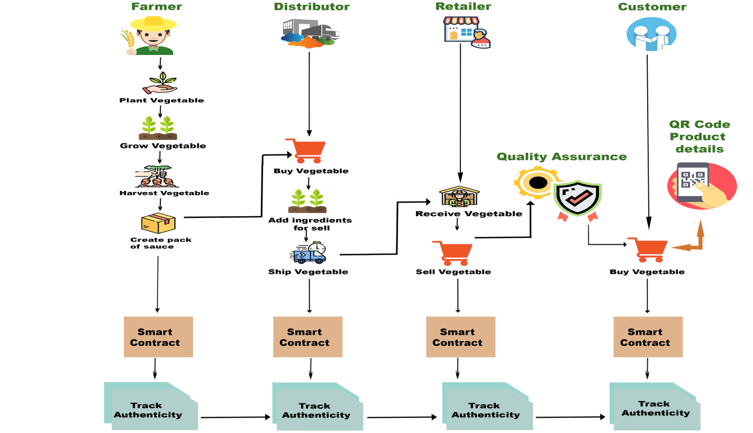

Fig. 5.1: System architecture

**DATA FLOW DIAGRAM:**

1. The DFD is also called as bubble chart. It is a simple graphical formalism that can be used to represent a system in terms of input data to the system, various processing carried out on this data, and the output data is generated by this system.
2. The data flow diagram (DFD) is one of the most important modeling tools. It is used to model the system components. These components are the system process, the data used by the process, an external entity that interacts with the system and the information flows in the system.
3. DFD shows how the information moves through the system and how it is modified by a series of transformations. It is a graphical technique that depicts information flow and the transformations that are applied as data moves from input to output.
4. DFD is also known as bubble chart. A DFD may be used to represent a system at any level of abstraction. DFD may be partitioned into levels that represent increasing information flow and functional detail.

**Farmer register & login**

**VERIFY**

**YES**

**NO PROCESS**

**NO**

**Add vegetables**

**Distributor register & login**

**Add vegetables & ingredients**

**Retailer register & login**

**Sell vegetables & generate QR code**

**Customer register & login**

**Authenticate scan & buy vegetable**

**End process**

**Fig.5.1.2 Dataflow diagrams**

**5.2 UML DIAGRAMS**

UML stands for Unified Modeling Language. UML is a standardized general-purpose modeling language in the field of object-oriented software engineering. The standard is managed, and was created by, the Object Management Group.

The goal is for UML to become a common language for creating models of object oriented computer software. In its current form UML is comprised of two major components: a Meta-model and a notation. In the future, some form of method or process may also be added to; or associated with, UML.

The Unified Modeling Language is a standard language for specifying, Visualization, Constructing and documenting the artifacts of software system, as well as for business modeling and other non-software systems.

The UML represents a collection of best engineering practices that have proven successful in the modeling of large and complex systems.

The UML is a very important part of developing objects oriented software and the software development process. The UML uses mostly graphical notations to express the design of software projects.

**GOALS:**

The Primary goals in the design of the UML are as follows:

1. Provide users a ready-to-use, expressive visual modeling Language so that they can develop and exchange meaningful models.
2. Provide extendibility and specialization mechanisms to extend the core concepts.
3. Be independent of particular programming languages and development process.
4. Provide a formal basis for understanding the modeling language.
5. Encourage the growth of OO tools market.
6. Support higher level development concepts such as collaborations, frameworks, patterns and components.
7. Integrate best practices.

**Use case diagram:**

A use case diagram in the Unified Modeling Language (UML) is a type of behavioral diagram defined by and created from a Use-case analysis. Its purpose is to present a graphical overview of the functionality provided by a system in terms of actors, their goals (represented as use cases), and any dependencies between those use cases. The main purpose of a use case diagram is to show what system functions are performed for which actor. Roles of the actors in the system can be depicted.

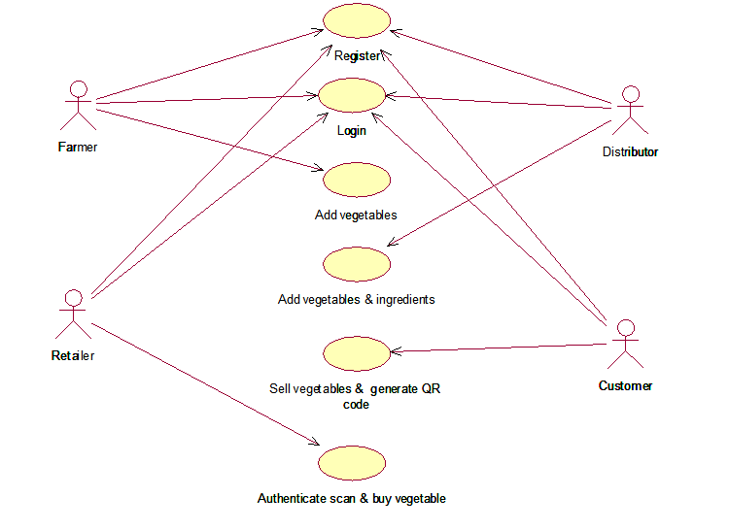

**Fig.5.2.1 Use Case diagram**

**Class diagram:**

The class diagram is used to refine the use case diagram and define a detailed design of the system. The class diagram classifies the actors defined in the use case diagram into a set of interrelated classes. The relationship or association between the classes can be either an "is-a" or "has-a" relationship. Each class in the class diagram may be capable of providing certain functionalities. These functionalities provided by the class are termed "methods" of the class. Apart from this, each class may have certain "attributes" that uniquely identify the class.

Elucidating hierarchical structures and compositions within the system. Additionally, the diagram may illustrate visibility modifiers, delineating the accessibility of attributes and methods, alongside multiplicity annotations, denoting the cardinality of associations between classes.

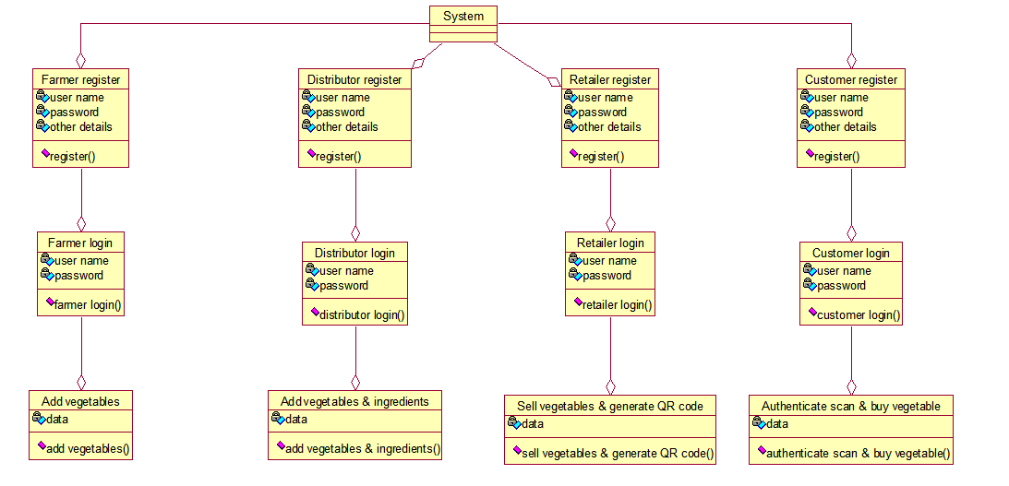

**Fig.5.2.2 Class diagram**

**Activity diagram:**

The activity diagram serves as a vital tool for depicting the flow of processes within the system. Much like a state diagram, it encapsulates various elements such as activities, actions, transitions, initial and final states, and guard conditions. These components collectively illustrate the sequence of actions undertaken by the system or its actors to accomplish specific tasks or goals. Activities represent the tasks or operations performed, while actions denote the individual steps within these tasks. Transitions delineate the flow of control between activities, depicting the progression from one state to another. Additionally, initial and final states mark the beginning and end points of the diagram, respectively, framing the sequence of activities.

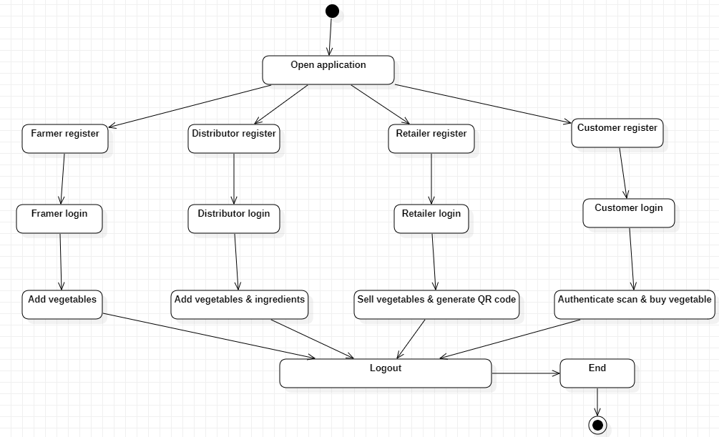

**Fig.5.2.3 Activity diagram**

**Sequence diagram:**

A sequence diagram represents the interaction between different objects in the system. The important aspect of a sequence diagram is that it is time-ordered. This means that the exact sequence of the interactions between the objects is represented step by step. Different objects in the sequence diagram interact with each other by passing "messages".

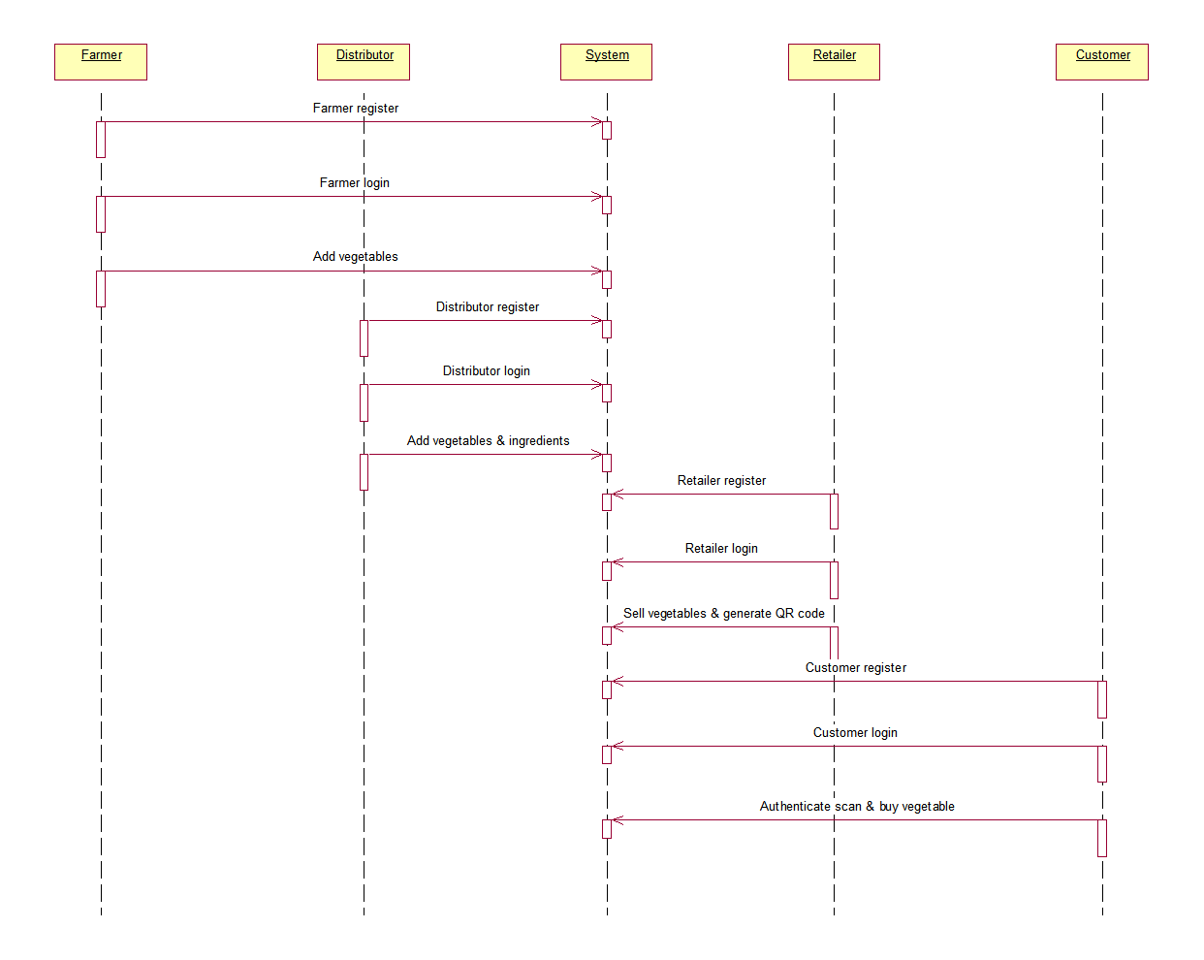

**Fig.5.2.4 Sequence diagram**

**Collaboration diagram:**

A collaboration diagram groups together the interactions between different objects. The interactions are listed as numbered interactions that help to trace the sequence of the interactions. The collaboration diagram helps to identify all the possible interactions that each object has with other objects.

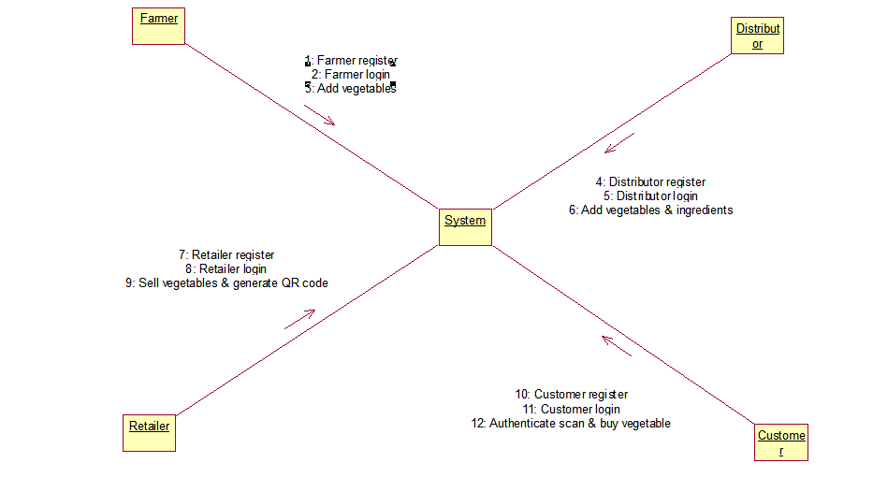

**Fig.5.2.5 Collaboration diagram**

**Component diagram:**

The component diagram provides a high-level overview of the system's architecture by illustrating the constituent parts that compose it. At its core, this diagram delineates the various components that constitute the system and elucidates their interrelationships. These components, which are identified after the system has undergone development or construction, encompass modules, libraries, executables, and other encapsulated units of functionality. Through the depiction of these components and their associations, the diagram offers insights into the structural organization of the system, highlighting dependencies, interfaces, and interactions between different parts. Moreover, it serves as a blueprint for understanding the system's modular design, facilitating modifiability, scalability, and maintainability. By providing a visual representation of the system's components and their relationships, the component diagram aids in the comprehension, analysis, and communication of the system's architecture amongst stakeholders, fostering collaboration and alignment towards achieving the system's objectives.

The component diagram represents the high-level parts that make up the system. This diagram depicts, at a high level, what components form part of the system and how they are interrelated. A component diagram depicts the components culled after the system has undergone the development or construction phase.

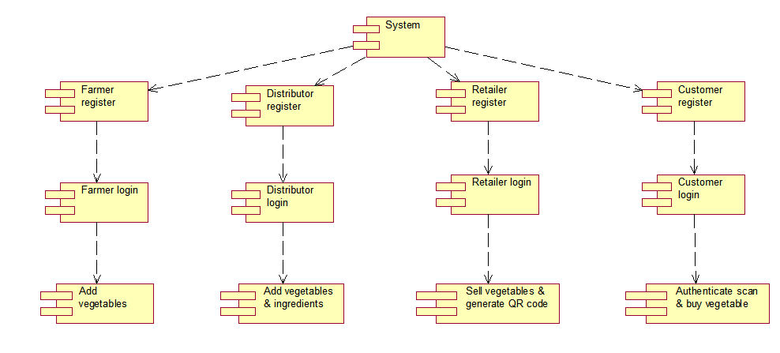

**Fig.5.2.6 Component diagram**

**Deployment diagram:**

The deployment diagram serves as a crucial tool for visualizing the configuration of the runtime elements of an application. Unlike other diagrams that focus on design or development stages, the deployment diagram specifically addresses the deployment phase of a system's lifecycle. It depicts the physical or virtual resources and how they are interconnected to support the execution of the system. These resources may include hardware nodes, software components, databases, servers, and communication channels, the diagram provides valuable insights into how the system will be distributed across different nodes or environments. It showcases the allocation of components to specific hardware or software platforms, indicating where each component will be deployed and how they interact with each other.

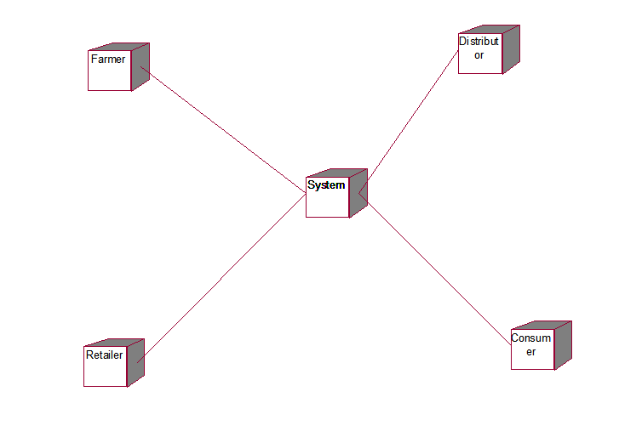

**Fig.5.2.7 Deployment diagram**

1. **IMPLEMENTATION**

**1) Farmer Register -** This module allows farmers involved in organic food production to sign up on the platform. During registration, farmers provide essential details such as their personal information, farm location, and certifications related to organic farming practices. Registration ensures that verified and legitimate farmers are part of the supply chain network.

**2) Farmer Login:** After successful registration, farmers can log in to the platform using their unique credentials. Logging in grants them access to various features and functionalities within the system, allowing them to interact with other stakeholders and contribute information about their produce.

**3) Add Vegetables :** Registered farmers use this module to input detailed information about the organic vegetables they cultivate. This includes specifics about the types of vegetables grown, the quantity produced, details about cultivation practices, and certifications obtained. Adding these details ensures transparency and authenticity in the supply chain.

**4) Distributor Register:** Distributors involved in the distribution of organic produce can register on the platform using this module. During registration, they provide business-related information, certifications, and contact details. Their registration ensures a network of verified distributors in the supply chain.

**5) Distributor Login:** Once registered, distributors log in to the platform using their credentials. Access to the system allows them to contribute information about received vegetables from farmers and any additional ingredients used in packaging or processing. This step aims to maintain transparency throughout the distribution process.

**6) Retailer Register:** Retailers involved in selling organic produce can register on the platform. During registration, they provide business details, location, and relevant certifications. Retailer registration ensures the inclusion of verified sellers in the supply chain network.

**7) Retailer Login:** After successful registration, retailers log in to the platform. This login grants them access to features related to selling vegetables to customers. They can list products for sale and access functionalities relevant to their role in the supply chain.

**8) Sell Vegetables and Generate QR Code:** Registered retailers can list and sell organic vegetables to customers through the platform. Upon sale, retailers generate a unique QR code associated with the product. This QR code provides customers with traceability and authenticity information about the purchased organic vegetables.

**9) Customer Register:** Customers interested in purchasing organic produce can create an account on the platform. During registration, they provide basic information and preferences related to their buying behavior.

**10) Customer Login:** After successful registration, customers log in to the platform using their credentials. Logging in enables them to access features such as product authentication and the purchase of organic vegetables.

**11) Authenticate Scan:** Customers use their smartphones to scan the QR code on the vegetable they intend to purchase. Scanning authenticates the product's origin, quality, and certifications, providing customers with confidence in the authenticity of the product they are purchasing.

**12) Buy Vegetable:** After successful authentication, customers can proceed to purchase the organic vegetables through the platform, ensuring that they receive genuine and certified organic produce.

These modules collectively create an integrated and transparent supply chain ecosystem, utilizing blockchain technology to ensure traceability, transparency, and authenticity of organic produce from farmers to consumers.

**BLOCKCHAIN INTEGRATION**

1)The project's core focus is on integrating blockchain technology into the organic food supply chain system. The aim is to bolster data security by adopting a decentralized, blockchain-based system. This system is designed to guarantee the authenticity and quality of organic products by leveraging the security features inherent in blockchain.

2) Blockchain technology provides a transparent, secure, and auditable platform for recording and distributing transactions within the supply chain. Each block in the blockchain is encrypted, ensuring that information remains secure and unmodifiable. This encryption prevents unauthorized access or alteration of the data stored within the blocks.

3)The integration of blockchain technology allows participants in the supply chain to monitor the status of products and trace the origins of raw materials. This capability ensures the authenticity of the end products. Furthermore, it enhances transparency, scalability, and security within the supply chain system, providing stakeholders with a comprehensive view of the product journey.

4) By leveraging blockchain technology, the project aims to tackle the issues of transparency and data tampering that commonly plague traditional supply chain systems. Blockchain ensures the immutability of data, guaranteeing that information remains unchanged throughout the product life cycle. This feature significantly reduces the risk of data manipulation and ensures the integrity of the supply chain records.

**6.2 SAMPLE CODE:**

|  |
| --- |
| #!/usr/bin/env python |
|  |  |
|  | # from datetime import datetime, date |
|  | from time import sleep |
|  | from argparse import ArgumentParser |
|  |  |
|  | import logging |
|  |  |
|  | from pyepm import api, config, __version__ |
|  | from bitcoin import * # NOQA |
|  |  |
|  | from urllib import urlopen |
|  |  |
|  | # Warning !!! |
|  | # to make things work, also at https://github.com/etherex/pyepm/blob/master/pyepm/api.py#L38 |
|  | # (method abi_data, before last return) |
|  | # need to implement fix for hex with odd length |
|  | # if len(data_abi) % 2 > 0: |
|  | # data_abi = data_abi.replace('0x','0x0') |
|  |  |
|  | BITCOIN_MAINNET = 'btc' |
|  | BITCOIN_TESTNET = 'testnet' |
|  | SLEEP_TIME = 5 * 60 # 5 mins. If changing, check retry logic |
|  | GAS_FOR_STORE_HEADERS = 1200000 # it should take less than 1M gas, but buffer to avoid running out |
|  |  |
|  | CHUNK_SIZE = 5 # number of headers to fetch at a time |
|  | CHUNK_RANGE = range(CHUNK_SIZE) |
|  |  |
|  | api_config = config.read_config() |
|  | instance = api.Api(api_config) |
|  |  |
|  | logging.basicConfig(format='%(message)s', level=logging.INFO) |
|  | logger = logging.getLogger(__name__) |
|  |  |
|  | pyepmLogger = logging.getLogger("pyepm") |
|  | pyepmLogger.setLevel(logging.INFO) |
|  |  |
|  | # instance.address = "0xcd2a3d9f938e13cd947ec05abc7fe734df8dd826" |
|  | # instance.relayContract = "0xba164d1e85526bd5e27fd15ad14b0eae91c45a93" |
|  | # TESTNET relay: 0x142f674e911cc55c226af81ac4d6de0a671d4abf |
|  |  |
|  | # To use a wallet, deploy and configure https://github.com/ethereum/dapp-bin/blob/69cb5e8c82074b5fbf9c01f75145c3cad5af85e2/wallet/wallet.sol |
|  | # Update the 4 wallet variables below. Using an instance of the contract wallet |
|  | # can allow more ETH to be stored in the wallet, while a much smaller amount of |
|  | # ETH can be stored in the "--sender" unlocked account. The "sender" can request |
|  | # a daily amount from the contract wallet, and should be unable to fully withdraw from |
|  | # the contract wallet if it has been deployed and configured correctly. |
|  | useWallet = False # when True, need to set the following remaining values: |
|  | instance.walletContract = '' # address of the contract wallet |
|  | instance.weiRefill = int(1e18) # 1 ETH. Amount to refill the "hot" sender account each time walletWithdraw() is called |
|  | aWalletOwner = '' # address of an owner of the contract wallet |
|  |  |
|  | def get_hash_by_height(height,network='btc'): |
|  | url = 'https://blockchain.info/block-height/'+str(height)+'?format=json' |
|  | jsonurl = urlopen(url) |
|  | text = json.loads(jsonurl.read()) |
|  | return text['blocks'][0]['hash'] |
|  |  |
|  | def serialize_header(height,network='btc'): |
|  | url = 'https://blockchain.info/block-height/'+str(height)+'?format=json' |
|  | jsonurl = urlopen(url) |
|  | text = json.loads(jsonurl.read()) |
|  | inp = text['blocks'][0] |
|  |  |
|  | o = encode(inp['ver'], 256, 4)[::-1] + \ |
|  | inp['prev_block'].decode('hex')[::-1] + \ |
|  | inp['mrkl_root'].decode('hex')[::-1] + \ |
|  | encode(inp['time'], 256, 4)[::-1] + \ |
|  | encode(inp['bits'], 256, 4)[::-1] + \ |
|  | encode(inp['nonce'], 256, 4)[::-1] |
|  | h = bin_sha256(bin_sha256(o))[::-1].encode('hex') |
|  | assert h == inp['hash'], (sha256(o), inp['hash']) |
|  | return o.encode('hex') |
|  |  |
|  | def main(): |
|  | # logging.basicConfig(level=logging.DEBUG) |
|  | logger.info("fetchd using PyEPM %s" % __version__) |
|  |  |
|  | parser = ArgumentParser() |
|  | parser.add_argument('-s', '--sender', required=True, help='sender of transaction') |
|  | parser.add_argument('-r', '--relay', required=True, help='relay contract address') |
|  |  |
|  | parser.add_argument('--rpcHost', default='127.0.0.1', help='RPC hostname') |
|  | parser.add_argument('--rpcPort', default='8545', type=int, help='RPC port') |
|  | parser.add_argument('--startBlock', default=0, type=int, help='block number to start fetching from') |
|  | parser.add_argument('-w', '--waitFor', default=0, type=int, help='number of blocks to wait between fetches') |
|  | parser.add_argument('--gasPrice', default=int(10e12), type=int, help='gas price') # default 10 szabo |
|  | parser.add_argument('--fetch', action='store_true', help='fetch blockheaders') |
|  | parser.add_argument('-n', '--network', default=BITCOIN_TESTNET, choices=[BITCOIN_TESTNET, BITCOIN_MAINNET], help='Bitcoin network') |
|  | parser.add_argument('-d', '--daemon', default=False, action='store_true', help='run as daemon') |
|  | parser.add_argument('--feeVTX', default=0, type=int, help='fee to charge for verifications') |
|  | parser.add_argument('--feeRecipient', help='address of fee recipient') |
|  |  |
|  | args = parser.parse_args() |
|  |  |
|  | instance.address = args.sender |
|  | instance.relayContract = args.relay |
|  |  |
|  | instance.rpcHost = args.rpcHost |
|  | instance.rpcPort = args.rpcPort |
|  | instance.jsonrpc_url = "http://%s:%s" % (instance.rpcHost, instance.rpcPort) |
|  |  |
|  | instance.numBlocksToWait = args.waitFor # for CPP eth as of Apr 28, 3 blocks seems reasonable. 0 seems to be fine for Geth |
|  | # instance.gasPrice = args.gasPrice |
|  |  |
|  | feeVerifyTx = args.feeVTX |
|  | logger.info('feeVTX: %s' % feeVerifyTx) |
|  |  |
|  | if useWallet: |
|  | if instance.walletContract == '' or aWalletOwner == '': |
|  | logger.info('wallet contract and owner address need to both be set') |
|  | sys.exit() |
|  | if instance.address != aWalletOwner: |
|  | logger.info('sender is not a wallet owner: %s' % instance.address) |
|  | sys.exit() |
|  |  |
|  | feeRecipient = args.feeRecipient or instance.address |
|  | logger.info('feeRecipient: %s' % feeRecipient) |
|  |  |
|  | if feeRecipient != instance.address and not useWallet: |
|  | logger.warn('feeRecipient %s is not sender %s and contract wallet is not used' % (feeRecipient, instance.address)) |
|  | sys.exit() |
|  |  |
|  | # logger.info('@@@ rpc: %s' % instance.jsonrpc_url) |
|  |  |
|  | # this can't be commented out easily since run() always does instance.heightToStartFetch = getLastBlockHeight() + 1 for retries |
|  | # contractHeight = getLastBlockHeight() # needs instance.relayContract to be set |
|  | # logger.info('@@@ contract height: {0} gp: {1}').format(contractHeight, instance.gasPrice) |
|  | # instance.heightToStartFetch = args.startBlock or contractHeight + 1 |
|  |  |
|  | # this will not handle exceptions or do retries. need to use -d switch if desired |
|  | if not args.daemon: |
|  | run(feeVerifyTx, feeRecipient, doFetch=args.fetch, network=args.network, startBlock=args.startBlock) |
|  | return |
|  |  |
|  | while True: |
|  | for i in range(4): |
|  | try: |
|  | run(feeVerifyTx, feeRecipient, doFetch=args.fetch, network=args.network, startBlock=args.startBlock) |
|  | sleep(SLEEP_TIME) |
|  | except Exception as e: |
|  | logger.info(e) |
|  | logger.info('Retry in 1min') |
|  | sleep(60) |
|  | continue |
|  | except: # catch *all* exceptions |
|  | e = sys.exc_info()[0] |
|  | logger.info(e) |
|  | logger.info('Rare exception') |
|  | raise |
|  | break |
|  |  |
|  |  |
|  | def run(feeVerifyTx, feeRecipient, doFetch=False, network=BITCOIN_TESTNET, startBlock=0): |
|  | chainHead = getBlockchainHead() |
|  | if not chainHead: |
|  | raise ValueError("Empty BlockchainHead returned.") |
|  | chainHead = blockHashHex(chainHead) |
|  | logger.info('BTC BlockchainHead: %s' % chainHead) |
|  |  |
|  | # loop in case contract stored correct HEAD, but reorg in *Ethereum* chain |
|  | # so that contract lost the correct HEAD. we try 3 times since it would |
|  | # be quite unlucky for 5 Ethereum reorgs to coincide with storing the |
|  | # non-orphaned Bitcoin block |
|  | nTime = 5 |
|  | for i in range(nTime): |
|  | # refetch if needed in case contract's HEAD was orphaned |
|  | if startBlock: |
|  | contractHeight = startBlock |
|  | else: |
|  | contractHeight = getLastBlockHeight() |
|  | realHead = get_hash_by_height(contractHeight, network=network) |
|  | heightToRefetch = contractHeight |
|  | while chainHead != realHead: |
|  | logger.info('@@@ chainHead: {0} realHead: {1}'.format(chainHead, realHead)) |
|  | fetchHeaders(heightToRefetch, 1, 1, feeVerifyTx, feeRecipient, network=network) |
|  |  |
|  | # wait for some blocks because Geth has a delay (at least in RPC), of |
|  | # returning the correct data. the non-orphaned header may already |
|  | # be in the Ethereum blockchain, so we should give it a chance before |
|  | # adjusting realHead to the previous parent |
|  | # |
|  | # realHead is adjusted to previous parent in the off-chance that |
|  | # there is more than 1 orphan block |
|  | # for j in range(4): |
|  | instance.wait_for_next_block(from_block=instance.last_block(), verbose=True) |
|  |  |
|  | chainHead = blockHashHex(getBlockchainHead()) |
|  | realHead = get_hash_by_height(heightToRefetch, network=network) |
|  |  |
|  | heightToRefetch -= 1 |
|  |  |
|  | if heightToRefetch < contractHeight - 10: |
|  | if i == nTime - 1: |
|  | # this really shouldn't happen since 2 orphans are already |
|  | # rare, let alone 10 |
|  | logger.info('@@@@ TERMINATING big reorg? {0}'.format(heightToRefetch)) |
|  | sys.exit() |
|  | else: |
|  | logger.info('@@@@ handle orphan did not succeed iteration {0}'.format(i)) |
|  | break # start the refetch again, this time ++i |
|  | break # chainHead is same realHead |
|  |  |
|  | actualHeight = last_block_height(network) # pybitcointools 1.1.33 |
|  |  |
|  | if startBlock: |
|  | instance.heightToStartFetch = startBlock |
|  | else: |
|  | instance.heightToStartFetch = getLastBlockHeight() + 1 |
|  |  |
|  | logger.info('@@@ startFetch: {0} actualHeight: {1}'.format(instance.heightToStartFetch, actualHeight)) |
|  |  |
|  | chunkSize = CHUNK_SIZE |
|  | fetchNum = actualHeight - instance.heightToStartFetch + 1 |
|  | numChunk = fetchNum / chunkSize |
|  | leftoverToFetch = fetchNum % chunkSize |
|  |  |
|  | logger.info('@@@ numChunk: {0} leftoverToFetch: {1}'.format(numChunk, fetchNum)) |
|  | logger.info('----------------------------------') |
|  |  |
|  | if doFetch: |
|  | fetchHeaders(instance.heightToStartFetch, chunkSize, numChunk, feeVerifyTx, feeRecipient, network=network) |
|  | fetchHeaders(actualHeight - leftoverToFetch + 1, 1, leftoverToFetch, feeVerifyTx, feeRecipient, network=network) |
|  | # sys.exit() |
|  |  |
|  |  |
|  | def fetchHeaders(chunkStartNum, chunkSize, numChunk, feeVerifyTx, feeRecipient, network=BITCOIN_TESTNET): |
|  | for j in range(numChunk): |
|  | strings = "" |
|  | for i in range(chunkSize): |
|  | blockNum = chunkStartNum + i |
|  | bhStr = serialize_header(blockNum, network=network) |
|  | logger.info("@@@ {0}: {1}".format(blockNum, bhStr)) |
|  | logger.debug("Block header: %s" % repr(bhStr.decode('hex'))) |
|  | strings += bhStr |
|  |  |
|  | storeHeaders(strings.decode('hex'), chunkSize, feeVerifyTx, feeRecipient) |
|  |  |
|  | chainHead = getBlockchainHead() |
|  | logger.info('@@@ DONE hexHead: %s' % blockHashHex(chainHead)) |
|  | logger.info('==================================') |
|  |  |
|  | chunkStartNum += chunkSize |
|  |  |
|  |  |
|  | # average of 6*24=144 headers a day. So AROUND every 100 headers we check |
|  | # the balance of sender and if it's less than 1 ETH, we ask for more ETH |
|  | # from the wallet. |
|  | # CHUNK_RANGE is used when chunkSize>1 so that we ask for ETH if chunkStartNum ends in |
|  | # ????00, ????01, ????02 to ????04 |
|  | if ((chunkSize == 1 and chunkStartNum % 100 == 0) or |
|  | (chunkSize == CHUNK_SIZE and chunkStartNum % 100 in CHUNK_RANGE)) and useWallet: |
|  | myWei = instance.balance_at(instance.address) |
|  | myBalance = myWei / 1e18 |
|  | logger.info('myBalance ETH: %s' % myBalance) |
|  |  |
|  | if myBalance < 1: |
|  | logger.info('going to walletWithdraw') |
|  | walletWithdraw() |
|  | myWei = instance.balance_at(instance.address) |
|  | myBalance = myWei / 1e18 |
|  | logger.info('topped up ETH balance: %s' % myBalance) |
|  |  |
|  |  |
|  | def storeHeaders(bhBytes, chunkSize, feeVerifyTx, feeRecipient): |
|  |  |
|  | txCount = instance.transaction_count(defaultBlock='pending') |
|  | logger.info('----------------------------------') |
|  | logger.info('txCount: %s' % txCount) |
|  |  |
|  | hashOne = blockHashHex(int(bin_dbl_sha256(bhBytes[:80])[::-1].encode('hex'), 16)) |
|  | hashLast = blockHashHex(int(bin_dbl_sha256(bhBytes[-80:])[::-1].encode('hex'), 16)) |
|  | logger.info('hashOne: %s' % hashOne) |
|  | logger.info('hashLast: %s' % hashLast) |
|  |  |
|  | firstH = bhBytes[:80].encode('hex') |
|  | lastH = bhBytes[-80:].encode('hex') |
|  | logger.info('firstH: %s' % firstH) |
|  | logger.info('lastH: %s' % lastH) |
|  |  |
|  | sig = 'bulkStoreHeader:[bytes,int256]:int256' |
|  |  |
|  | data = [bhBytes, chunkSize] |
|  |  |
|  | gas = GAS_FOR_STORE_HEADERS |
|  | value = 0 |
|  |  |
|  | # |
|  | # Store the headers |
|  | # |
|  |  |
|  | if feeVerifyTx != 0: |
|  | sig = 'storeBlockWithFeeAndRecipient:[bytes,int256,int256]:int256' |
|  |  |
|  | for i in range(chunkSize): |
|  | if feeVerifyTx != 0: |
|  | offset = 80*i |
|  | data = [ bhBytes[offset:offset+80] , feeVerifyTx, feeRecipient] |
|  |  |
|  | # Wait for the transaction and retry if failed |
|  | txHash = instance.transact(instance.relayContract, sig=sig, data=data, gas=gas, value=value) |
|  | logger.info("store header txHash: %s" % txHash) |
|  | txResult = False |
|  | while txResult is False: |
|  | txResult = instance.wait_for_transaction(transactionHash=txHash, defaultBlock="pending", retry=30, verbose=True) |
|  | logger.info("store header pendingblock txResult: %s" % txResult) |
|  | if txResult is False: |
|  | txHash = instance.transact(instance.relayContract, sig=sig, data=data, gas=gas, value=value) |
|  |  |
|  | # Wait for the transaction to be mined and retry if failed |
|  | txResult = False |
|  | while txResult is False: |
|  | txResult = instance.wait_for_transaction(transactionHash=txHash, defaultBlock="latest", retry=60, verbose=True) |
|  | logger.info("store header latestblock txResult: %s" % txResult) |
|  | if txResult is False: |
|  | txHash = instance.transact(instance.relayContract, sig=sig, data=data, gas=gas, value=value) |
|  |  |
|  | if feeVerifyTx == 0: |
|  | break |
|  |  |
|  | chainHead = getBlockchainHead() |
|  | expHead = int(bin_dbl_sha256(bhBytes[-80:])[::-1].encode('hex'), 16) |
|  |  |
|  | if chainHead != expHead: |
|  | logger.info('@@@@@ MISMATCH chainHead: {0} expHead: {1}'.format(blockHashHex(chainHead), blockHashHex(expHead))) |
|  | # sys.exit(1) |
|  |  |
|  |  |
|  | def walletWithdraw(): |
|  | # execute(address _to, uint _value, bytes _data) |
|  | sig = 'execute:[address,uint256,bytes]:bytes32' |
|  | data = [instance.address, instance.weiRefill, ''] |
|  | gas = 999000 |
|  |  |
|  | # Wait for the transaction retry if failed |
|  | txHash = instance.transact(instance.walletContract, sig=sig, data=data, gas=gas) |
|  | logger.info("walletWithdraw txHash: %s" % txHash) |
|  | txResult = False |
|  | while txResult is False: |
|  | txResult = instance.wait_for_transaction(transactionHash=txHash, defaultBlock="pending", retry=30, verbose=True) |
|  | if txResult is False: |
|  | txHash = instance.transact(instance.walletContract, sig=sig, data=data, gas=gas) |
|  |  |
|  | # Wait for the transaction to be mined and retry if failed |
|  | txResult = False |
|  | while txResult is False: |
|  | txResult = instance.wait_for_transaction(transactionHash=txHash, defaultBlock="latest", retry=60, verbose=True) |
|  | if txResult is False: |
|  | txHash = instance.transact(instance.walletContract, sig=sig, data=data, gas=gas) |
|  |  |
|  |  |
|  | def getLastBlockHeight(): |
|  | sig = 'getLastBlockHeight:[]:int256' |
|  | data = [] |
|  |  |
|  | pyepmLogger.setLevel(logging.WARNING) |
|  | callResult = instance.call(instance.relayContract, sig=sig, data=data) |
|  | pyepmLogger.setLevel(logging.INFO) |
|  | logger.debug("RESULT %s" % callResult) |
|  | chainHead = callResult[0] if len(callResult) else callResult |
|  | return chainHead |
|  |  |
|  |  |
|  | def getBlockchainHead(): |
|  | sig = 'getBlockchainHead:[]:int256' |
|  | data = [] |
|  |  |
|  | pyepmLogger.setLevel(logging.WARNING) |
|  | callResult = instance.call(instance.relayContract, sig=sig, data=data) |
|  | pyepmLogger.setLevel(logging.INFO) |
|  | chainHead = callResult[0] if len(callResult) else callResult |
|  | return chainHead |
|  |  |
|  |  |
|  | def blockHashHex(number): |
|  | hexHead = hex(number)[2:-1] # snip off the 0x and trailing L |
|  | hexHead = '0' * (64 - len(hexHead)) + hexHead |
|  | return hexHead |
|  |  |
|  | if __name__ == '__main__': |
|  | main() |

**7. SOFTWARE ENVIRONMENT**

**GANACHE**

* Ganache is a user-friendly interface for monitoring Ethereum blockchain activities. It simplifies tracking of accounts, transactions, and smart contracts, making it accessible even for users without in-depth blockchain expertise. Ganache offers detailed transaction information, including sender, receiver, amounts, gas usage, and success status, aiding debugging and ensuring transaction accuracy. It also tracks smart contract deployments, confirming correct deployment and functionality. This transparency simplifies monitoring and verification processes.
* Ganache lets us dive into the details of each block on the Ethereum blockchain. We can find out when a particular block was added, what transactions took place within it, and how much computing power (gas) was used. Ganache also enables data retrieval from stored blocks, allowing developers to access and analyze specific block information.

**METAMASK**

* Metamask is both an Ethereum wallet and a browser extension. It simplifies cryptocurrency management and provides direct access to DApps, making interactions with blockchain applications easier.
* In the project, Metamask ensures secure Ethereum transactions, promoting transparency by showing the deduction of ETH as fees. This transparency maintains accuracy and ensures confident, reliable financial interactions within the system.

**PYTHON LANGUAGE:**

Python is an interpreted, object-oriented, high-level programming language with dynamic semantics. Its high-level built in data structures, combined with dynamic typing and dynamic binding, make it very attractive for Rapid Application Development, as well as for use as a scripting or glue language to connect existing components together. Python's simple, easy to learn syntax emphasizes readability and therefore reduces the cost of program maintenance. Python supports modules and packages, which encourages program modularity and code reuse. The Python interpreter and the extensive standard library are available in source or binary form without charge for all major platforms, and can be freely distributed. Often, programmers fall in love with Python because of the increased productivity it provides. Since there is no compilation step, the edit-test-debug cycle is incredibly fast. Debugging Python programs is easy: a bug or bad input will never cause a segmentation fault. Instead, when the interpreter discovers an error, it raises an exception. When the program doesn't catch the exception, the interpreter prints a stack trace. A source level debugger allows inspection of local and global variables, evaluation of arbitrary expressions, setting breakpoints, stepping through the code a line at a time, and so on. The debugger is written in Python itself, testifying to Python's introspective power. On the other hand, often the quickest way to debug a program is to add a few print statements to the source: the fast edit-test-debug cycle makes this simple approach very effective.

Python is a dynamic, high-level, free open source, and interpreted programming language. It supports object-oriented programming as well as procedural-oriented programming. In Python, we don’t need to declare the type of variable because it is a dynamically typed language. For example, x = 10 Here, x can be anything such as String, int, etc.

## Features in Python:

There are many features in Python, some of which are discussed below as follows:

### **1. Free and Open Source**

[Python](https://www.geeksforgeeks.org/python-programming-language/)language is freely available at the official website and you can download it from the given download link below click on the **Download Python** keyword. [Download Python](https://www.python.org/downloads/) Since it is open-source, this means that source code is also available to the public. So you can download it, use it as well as share it.

### **2. Easy to code**

Python is a [high-level programming language](https://www.geeksforgeeks.org/difference-between-high-level-and-low-level-languages/). Python is very easy to learn the language as compared to other languages like C, C#, Javascript, Java, etc. It is very easy to code in the Python language and anybody can learn Python basics in a few hours or days. It is also a developer-friendly language.

### **3. Easy to Read**

As you will see, learning Python is quite simple. As was already established, Python’s syntax is really straightforward. The code block is defined by the indentations rather than by semicolons or brackets.

### **4. Object-Oriented Language**

One of the key features of [Python is Object-Oriented programming](https://www.geeksforgeeks.org/python-oops-concepts/). Python supports object-oriented language and concepts of classes, object encapsulation, etc.

### **5. GUI Programming Support**

Graphical User interfaces can be made using a module such as [PyQt5](https://www.geeksforgeeks.org/pyqt5-qaction/), PyQt4, wxPython, or [Tk in python](https://www.geeksforgeeks.org/python-gui-tkinter/). PyQt5 is the most popular option for creating graphical apps with Python.

### **6. High-Level Language**

Python is a high-level language. When we write programs in Python, we do not need to remember the system architecture, nor do we need to manage the memory.

### **7. Extensible feature**

Python is an **Extensible** language. We can write some Python code into C or C++ language and also we can compile that code in C/C++ language.

### **8. Easy to Debug**

Excellent information for mistake tracing. You will be able to quickly identify and correct the majority of your program’s issues once you understand how to [interpret](https://www.geeksforgeeks.org/difference-between-compiled-and-interpreted-language/)Python’s error traces. Simply by glancing at the code, you can determine what it is designed to perform.

### **9. Python is a Portable language**

Python language is also a portable language. For example, if we have Python code for windows and if we want to run this code on other platforms such as [Linux](https://www.geeksforgeeks.org/introduction-to-linux-operating-system/), Unix, and Mac then we do not need to change it, we can run this code on any platform.

### **10. Python is an Integrated language**

Python is also an integrated language because we can easily integrate Python with other languages like C, [C++](http://www.geeksforgeeks.org/c-plus-plus/), etc.

### **11. Interpreted Language:**

Python is an Interpreted Language because Python code is executed line by line at a time. like other languages C, C++, [Java](https://www.geeksforgeeks.org/java/), etc. there is no need to compile Python code this makes it easier to debug our code. The source code of Python is converted into an immediate form called **bytecode**.

### **12. Large Standard Library**

Python has a large [standard library](https://www.geeksforgeeks.org/libraries-in-python/) that provides a rich set of modules and functions so you do not have to write your own code for every single thing. There are many libraries present in Python such as [regular expression](https://www.geeksforgeeks.org/regular-expression-python-examples-set-1/)s, [unit-testing](https://www.geeksforgeeks.org/unit-testing-software-testing/), web browsers, etc.

### **13. Dynamically Typed Language**

Python is a dynamically-typed language. That means the type (for example- int, double, long, etc.) for a variable is decided at run time not in advance because of this feature we don’t need to specify the type of variable.

### **14. Frontend and backend development**

With a new project py script, you can run and write Python codes in HTML with the help of some simple tags <py-script>, <py-env>, etc. This will help you do frontend development work in Python like javascript. Backend is the strong forte of Python it’s extensively used for this work cause of its frameworks like [Django](https://www.geeksforgeeks.org/django-tutorial/)and [Flask](https://www.geeksforgeeks.org/flask-creating-first-simple-application/).

### **15. Allocating Memory Dynamically**

In Python, the variable data type does not need to be specified. The memory is automatically allocated to a variable at runtime when it is given a value. Developers do not need to write int y = 18 if the integer value 15 is set to y. You may just type y=18.

**LIBRARIES/ PACKGES:**

**Tensorflow**

TensorFlow is a [free](https://en.wikipedia.org/wiki/Free_software) and [open-source](https://en.wikipedia.org/wiki/Open-source_software) [software library for dataflow and differentiable programming](https://en.wikipedia.org/wiki/Library_(computing)) across a range of tasks. It is a symbolic math library, and is also used for [machine learning](https://en.wikipedia.org/wiki/Machine_learning) applications such as [neural networks](https://en.wikipedia.org/wiki/Neural_networks). It is used for both research and production at [Google](https://en.wikipedia.org/wiki/Google).‍

TensorFlow was developed by the [Google Brain](https://en.wikipedia.org/wiki/Google_Brain) team for internal Google use. It was released under the [Apache 2.0](https://en.wikipedia.org/wiki/Apache_License) [open-source license](https://en.wikipedia.org/wiki/Open-source_license) on November 9, 2015.

**Numpy**

Numpy is a general-purpose array-processing package. It provides a high-performance multidimensional array object, and tools for working with these arrays.

It is the fundamental package for scientific computing with Python. It contains various features including these important ones:

* A powerful N-dimensional array object
* Sophisticated (broadcasting) functions
* Tools for integrating C/C++ and Fortran code
* Useful linear algebra, Fourier transform, and random number capabilities

Besides its obvious scientific uses, Numpy can also be used as an efficient multi-dimensional container of generic data. Arbitrary data-types can be defined using Numpy which allows Numpy to seamlessly and speedily integrate with a wide variety of databases.

**Pandas**

Pandas is an open-source Python Library providing high-performance data manipulation and analysis tool using its powerful data structures. Python was majorly used for data munging and preparation. It had very little contribution towards data analysis. Pandas solved this problem. Using Pandas, we can accomplish five typical steps in the processing and analysis of data, regardless of the origin of data load, prepare, manipulate, model, and analyze. Python with Pandas is used in a wide range of fields including academic and commercial domains including finance, economics, Statistics, analytics, etc.

**Matplotlib**

Matplotlib is a Python 2D plotting library which produces publication quality figures in a variety of hardcopy formats and interactive environments across platforms. Matplotlib can be used in Python scripts, the Python and [IPython](http://ipython.org/) shells, the [Jupyter](http://jupyter.org/) Notebook, web application servers, and four graphical user interface toolkits. Matplotlib tries to make easy things easy and hard things possible. You can generate plots, histograms, power spectra, bar charts, error charts, scatter plots, etc., with just a few lines of code. For examples, see the [sample plots](https://matplotlib.org/tutorials/introductory/sample_plots.html) and [thumbnail gallery](https://matplotlib.org/gallery/index.html).

For simple plotting the pyplot module provides a MATLAB-like interface, particularly when combined with IPython. For the power user, you have full control of line styles, font properties, axes properties, etc, via an object oriented interface or via a set of functions familiar to MATLAB users.

**Scikit – learn**

Scikit-learn provides a range of supervised and unsupervised learning algorithms via a consistent interface in Python. It is licensed under a permissive simplified BSD license and is distributed under many Linux distributions, encouraging academic and commercial use.

**8. SYSTEM TESTING**

System testing, also referred to as system-level tests or system-integration testing, is the process in which a quality assurance (QA) team evaluates how the various components of an application interact together in the full, integrated system or application. System testing verifies that an application performs tasks as designed. This step, a kind of black box testing, focuses on the functionality of an application. System testing, for example, might check that every kind of user input produces the intended output across the application.

Phases of system testing:

A video tutorial about this test level. System testing examines every component of an application to make sure that they work as a complete and unified whole. A QA team typically conducts system testing after it checks individual modules with functional or user-story testing and then each component through integration testing.

If a software build achieves the desired results in system testing, it gets a final check via acceptance testing before it goes to production, where users consume the software. An app-dev team logs all defects, and establishes what kinds and amount of defects are tolerable.

**8.1Software Testing Strategies:**

Optimization of the approach to testing in software engineering is the best way to make it effective. A software testing strategy defines what, when, and how to do whatever is necessary to make an end-product of high quality. Usually, the following software testing strategies and their combinations are used to achieve this major objective:

Static Testing:

The early-stage testing strategy is static testing: it is performed without actually running the developing product. Basically, such desk-checking is required to detect bugs and issues that are present in the code itself. Such a check-up is important at the pre-deployment stage as it helps avoid problems caused by errors in the code and software structure deficits.

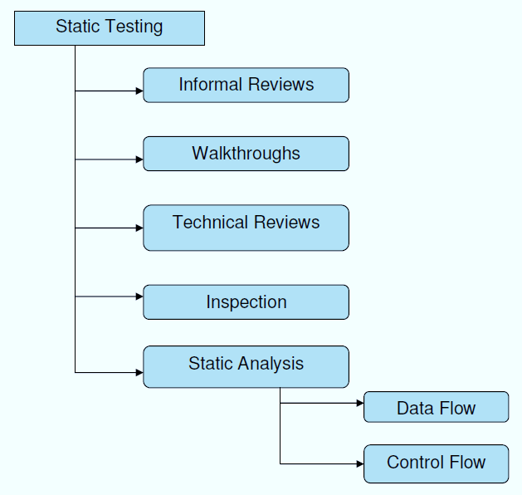

**Structural Testing:**

It is not possible to effectively test software without running it. Structural testing, also known as white-box testing, is required to detect and fix bugs and errors emerging during the pre-production stage of the software development process. At this stage, unit testing based on the software structure is performed using regression testing. In most cases, it is an automated process working within the test automation framework to speed up the development process at this stage. Developers and QA engineers have full access to the software’s structure and data flows (data flows testing), so they could track any changes (mutation testing) in the system’s behavior by comparing the tests’ outcomes with the results of previous iterations (control flow testing).

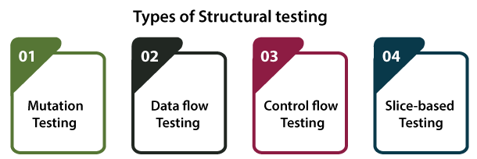

**Behavioral Testing:**

The final stage of testing focuses on the software’s reactions to various activities rather than on the mechanisms behind these reactions. In other words, behavioral testing, also known as black-box testing, presupposes running numerous tests, mostly manual, to see the product from the user’s point of view. QA engineers usually have some specific information about a business or other purposes of the software (‘the black box’) to run usability tests, for example, and react to bugs as regular users of the product will do. Behavioral testing also may include automation (regression tests) to eliminate human error if repetitive activities are required. For example, you may need to fill 100 registration forms on the website to see how the product copes with such an activity, so the automation of this test is preferable.

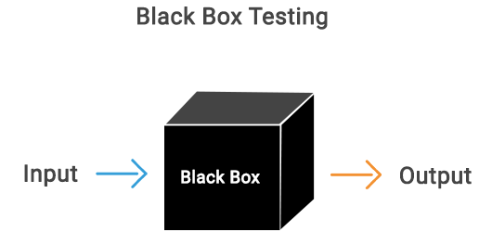

**8.2 TEST CASES:**

|  |  |  |  |
| --- | --- | --- | --- |
| **S.NO** | **INPUT** | **If available** | **If not available** |
| 1 | Add vegetables | Farmer can add vegetables | There is no process |
| 2 | Add vegetables & ingredients | Distributor can add vegetables & ingredients | There is no process |
| 3 | Sell vegetables & generate QR code | Retailer can sell vegetables & generate QR code | There is no process |
| 4 | Authenticate scan & buy vegetable | Customer can scan & buy vegetable | There is no process |

**9.RESULT SCREENS**

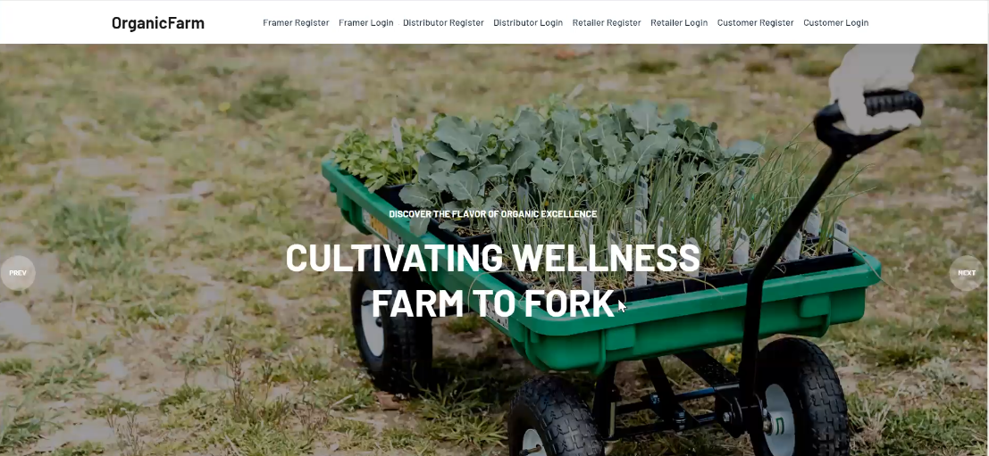

Screenshot:9.1 Home Page

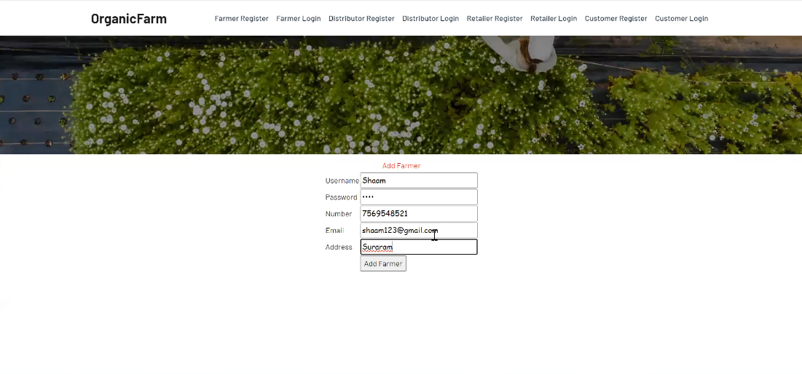

Screenshot:9.2 Farmer Registration

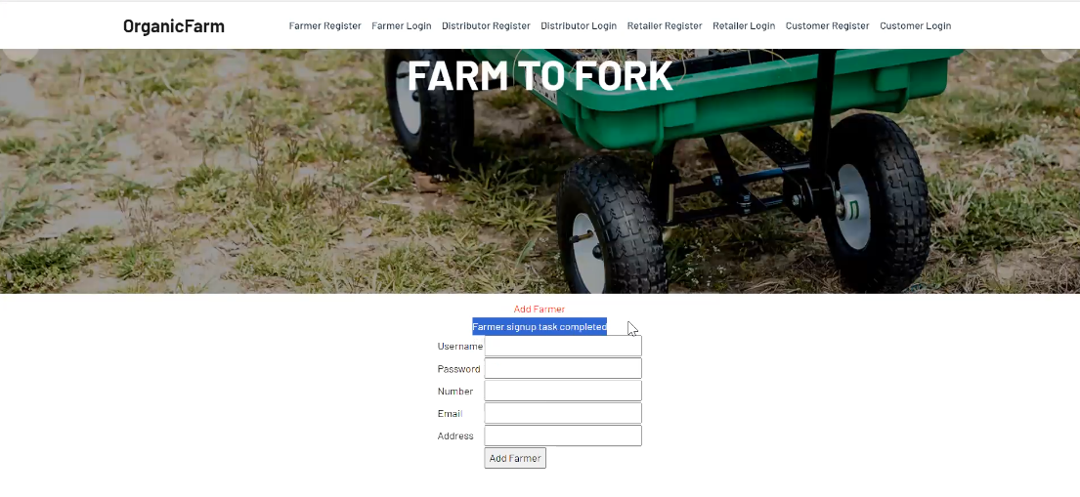

Screenshot:9.3 Farmer Registered Successfully

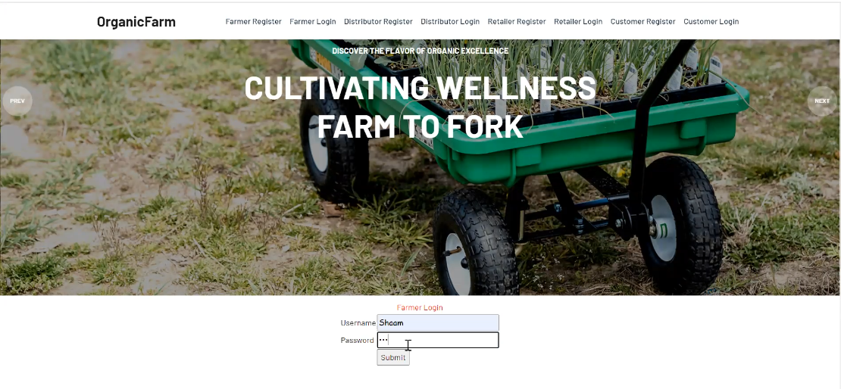

Screenshot:9.4 Farmer Login

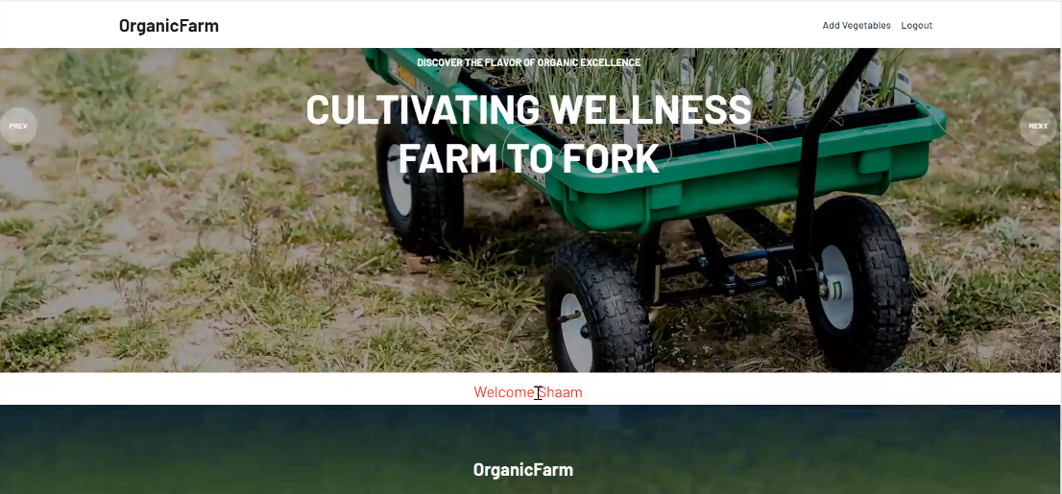

Screenshot:9.5 Farmer Login Successfully

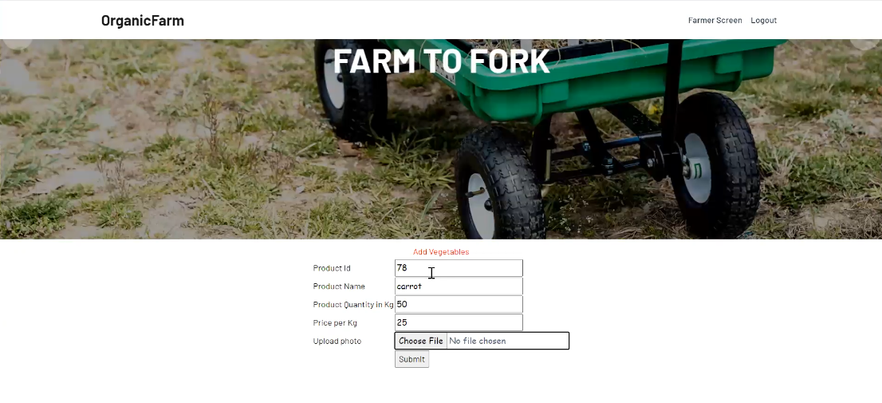

Screenshot:9.6 Farmer Adding Vegetables

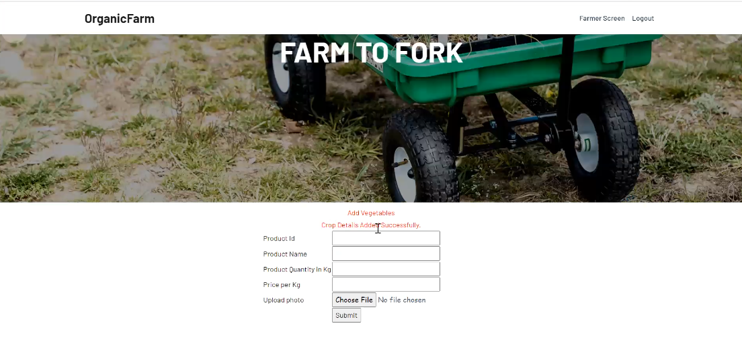

Screenshot:9.7 Vegetables Added Successfully

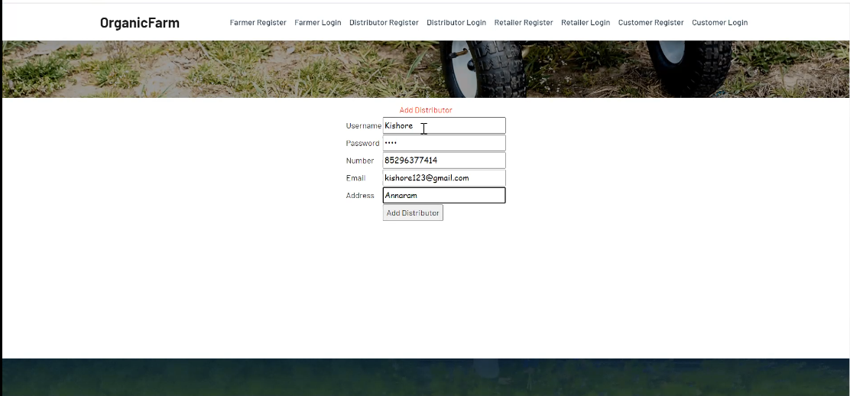

Screenshot:9.8 Distributor Registration

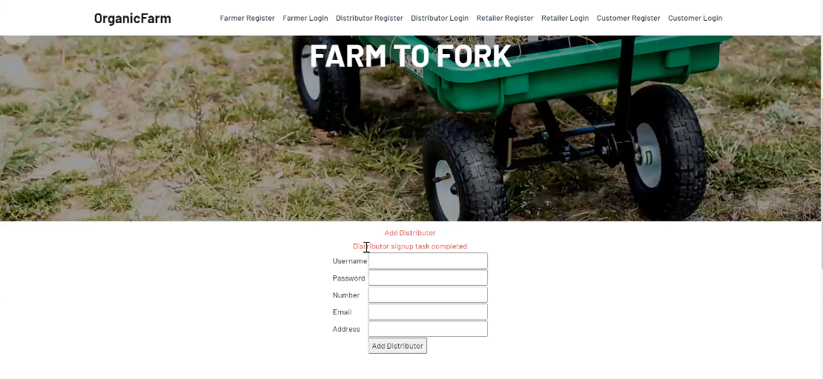

Screenshot:9.9 Distributor Registered Successfully

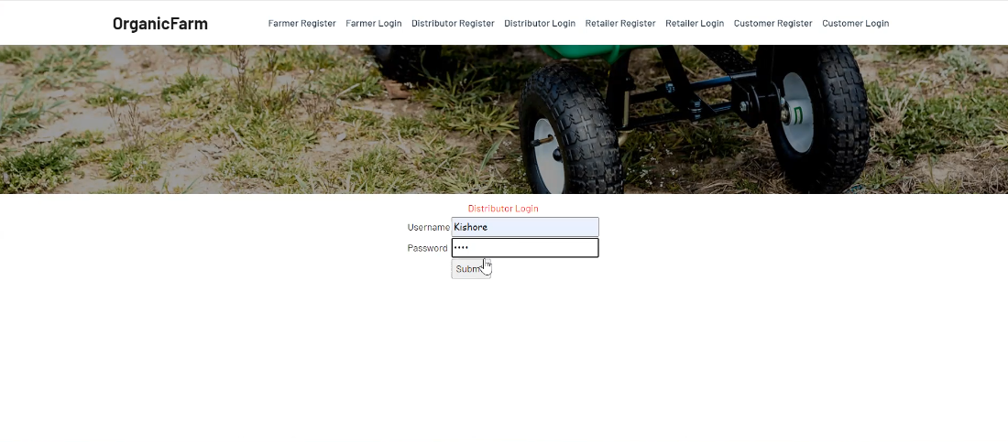

Screenshot:9.10 Distributor Login

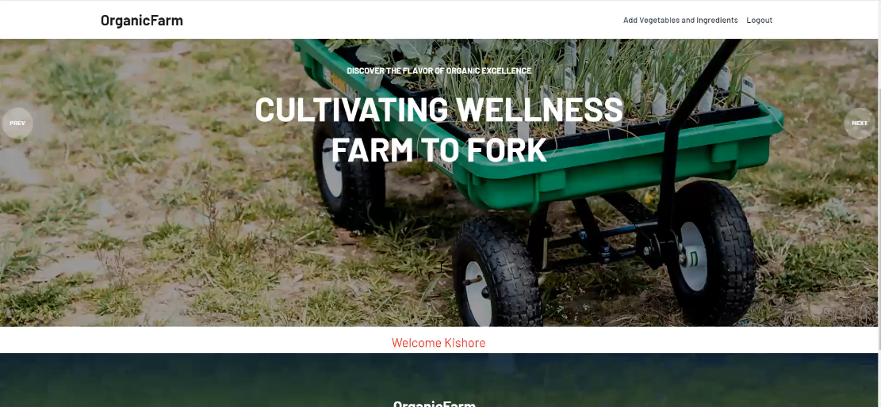

Screenshot:9.11 Distributor Screen

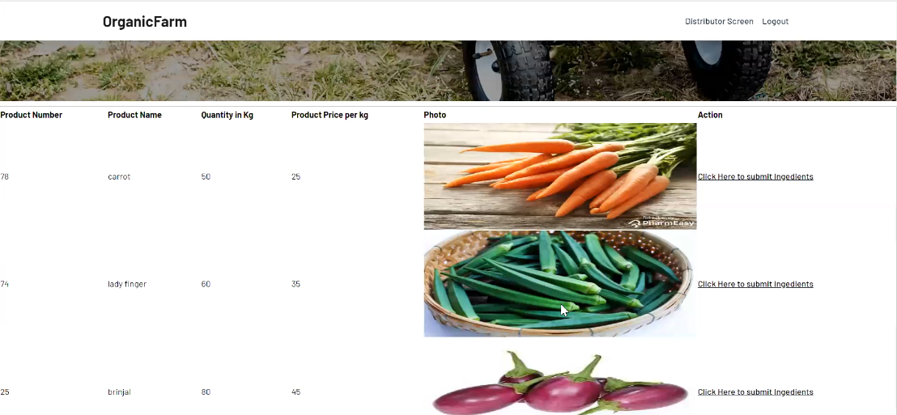

Screenshot:9.12 Distributor Screen 2

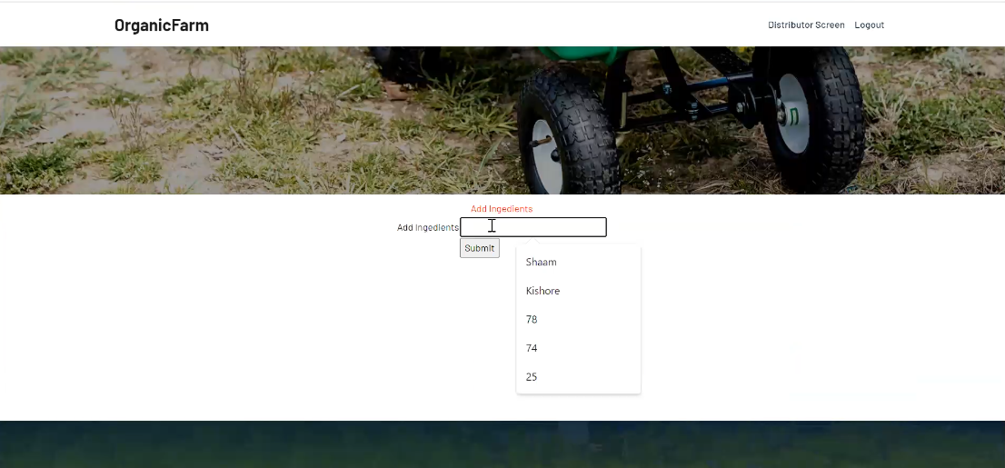

Screenshot:9.13 Distributor Adding Extra Information

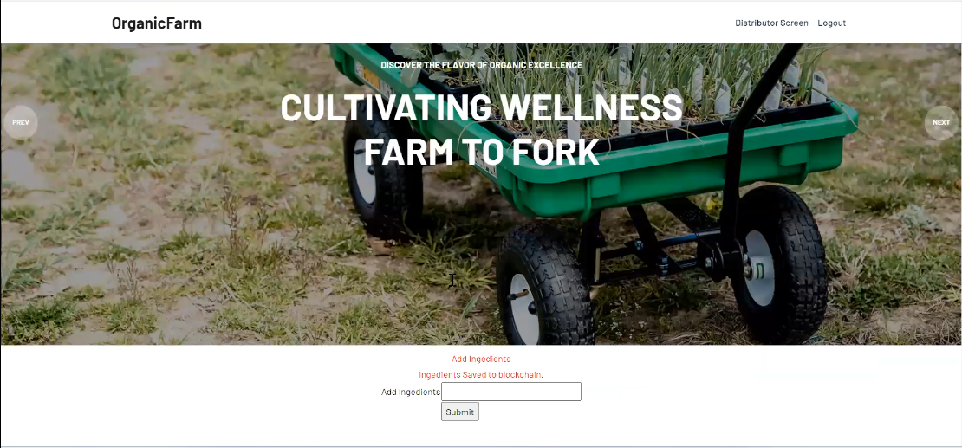

Screenshot:9.14 Distributor Added Information Successfully

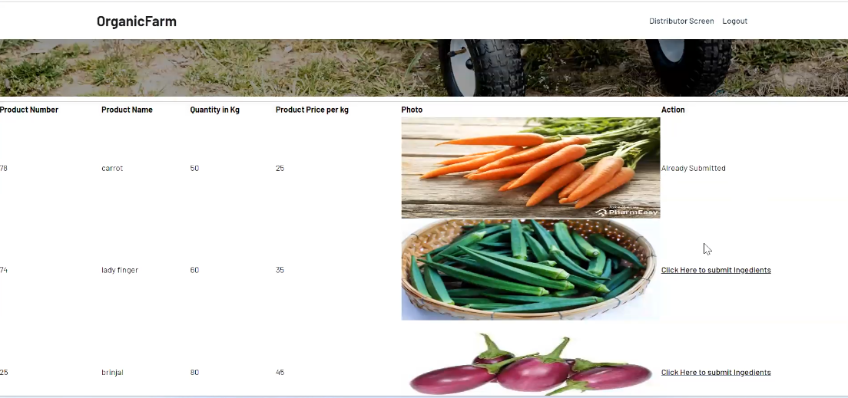

Screenshot:9.15 Distributor Screen

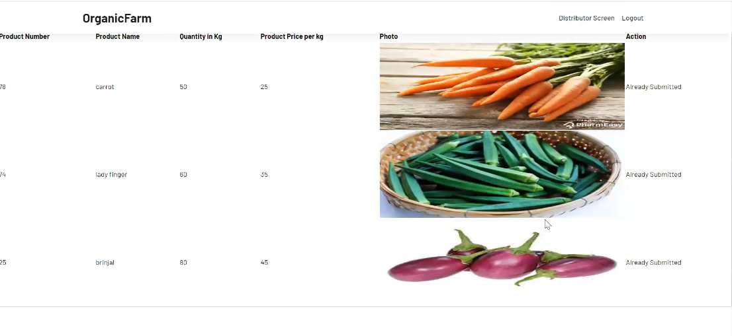 Screenshot:9.16 Distributor Screen

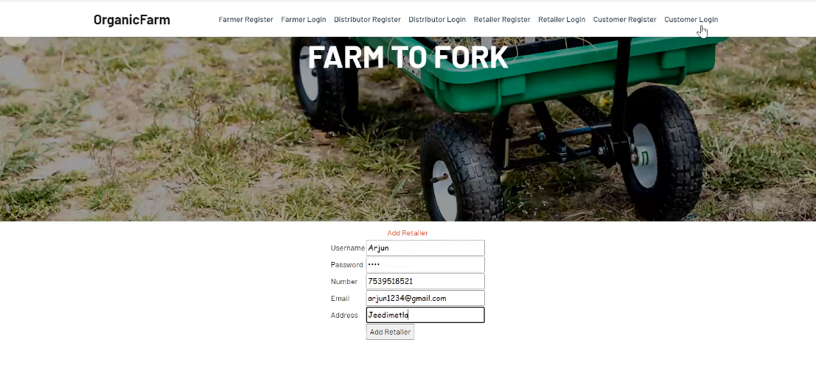

Screenshot:9.17 Retailer Registration

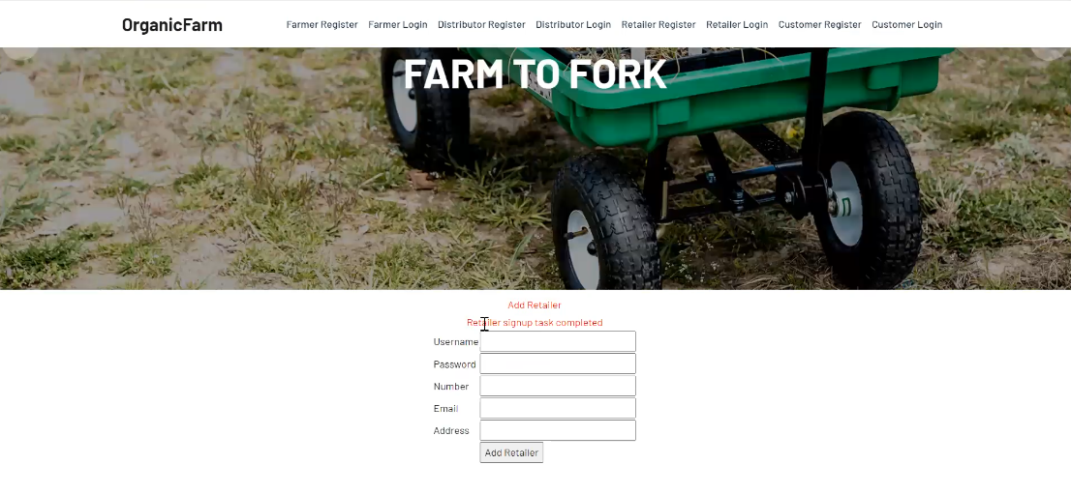

Screenshot:9.18 Retailer Registered Successfully

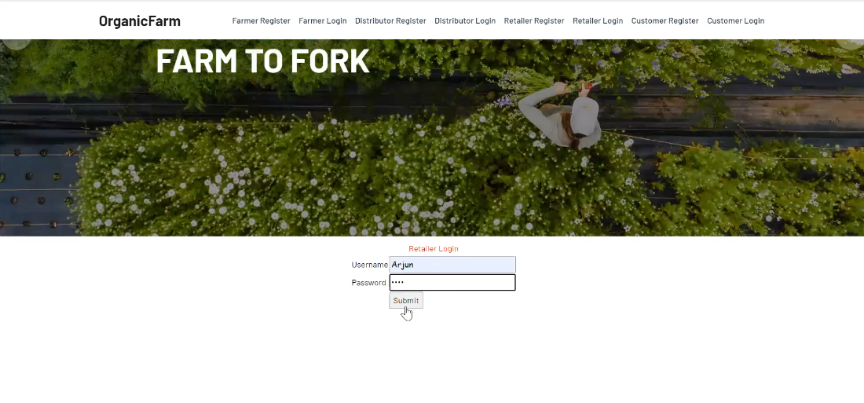

Screenshot:9.19 Retailer Login

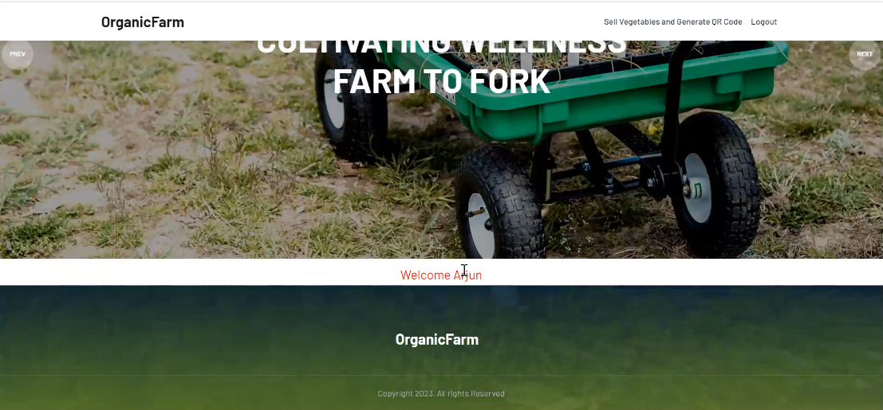

Screenshot:9.20 Retailer Screen

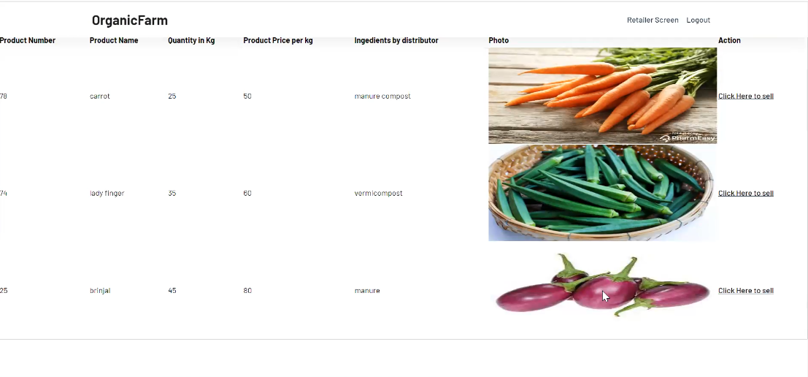

Screenshot:9.21 Retailer Screen

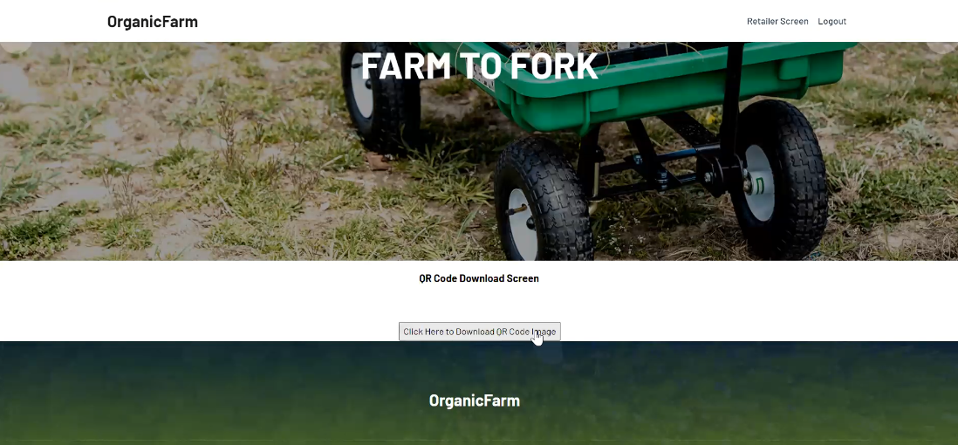

Screenshot:9.22 Retailer QR Generation Page

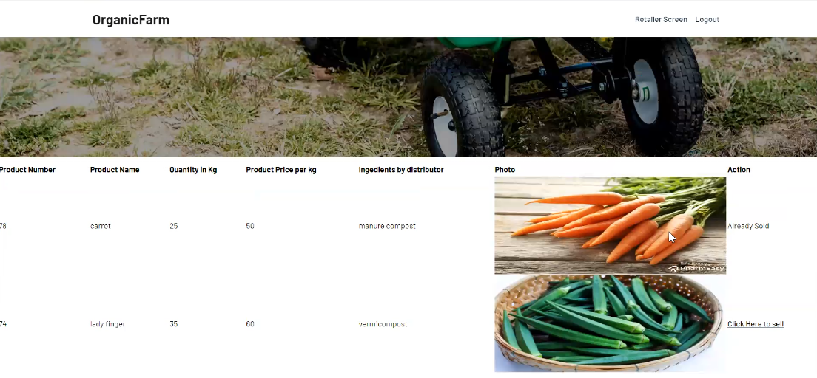

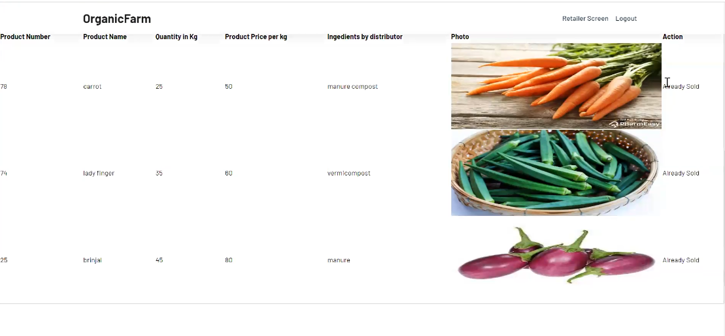

Screenshot:9.23 Retailer Screen

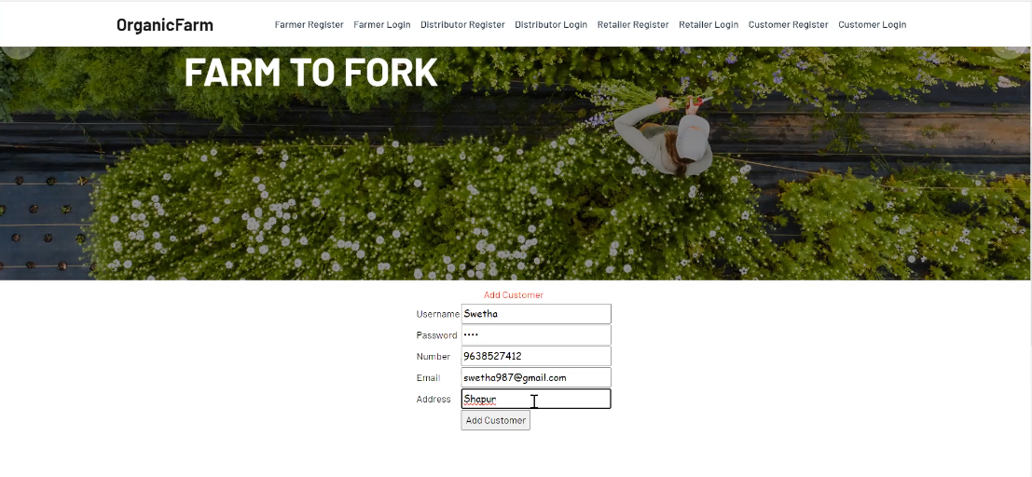

Screenshot:9.24 Customer Registration

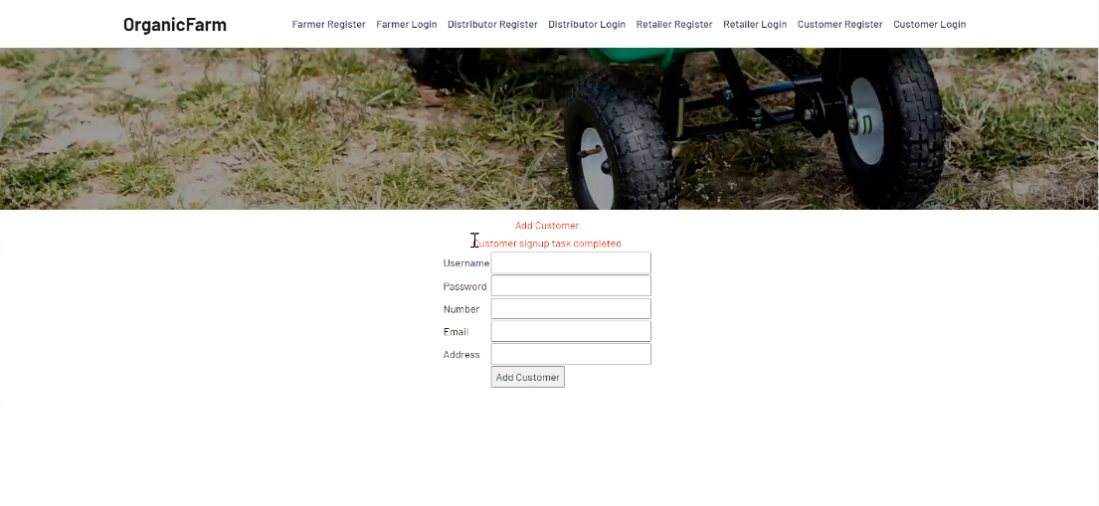

Screenshot:9.25 Customer Registered Successfully

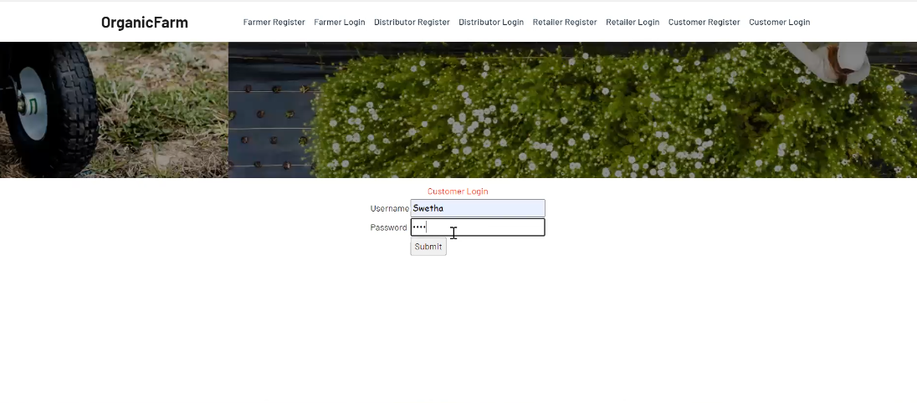

Screenshot:9.26 Customer Login

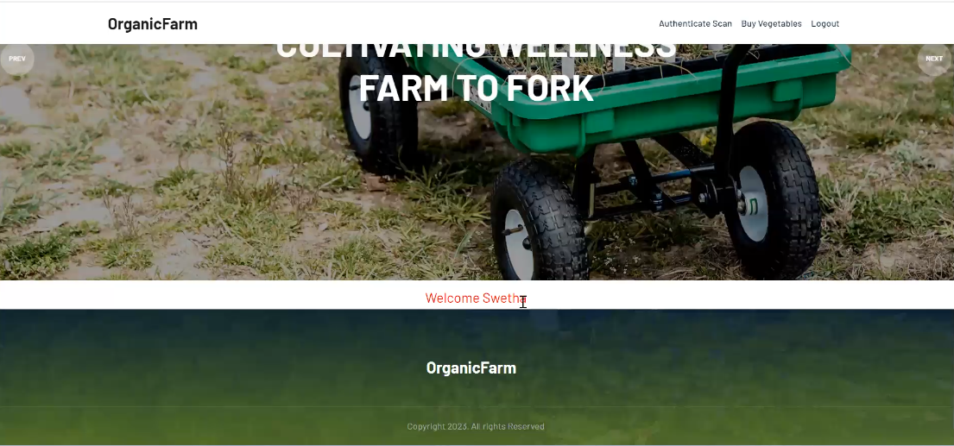

Screenshot:9.27 Customer Screen

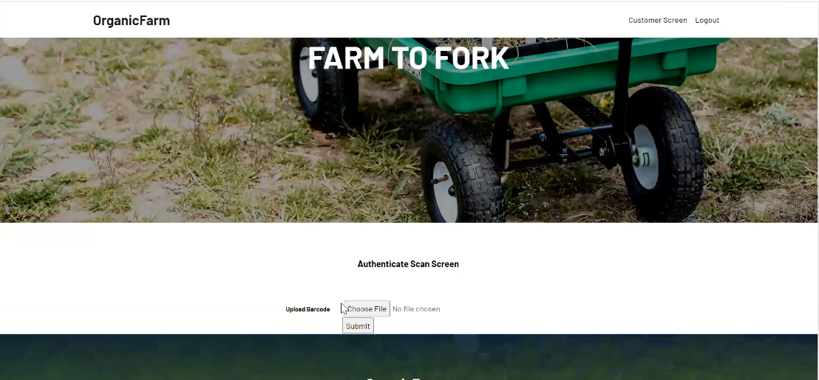

Screenshot:9.28 Customer Authenticate Scan Screen

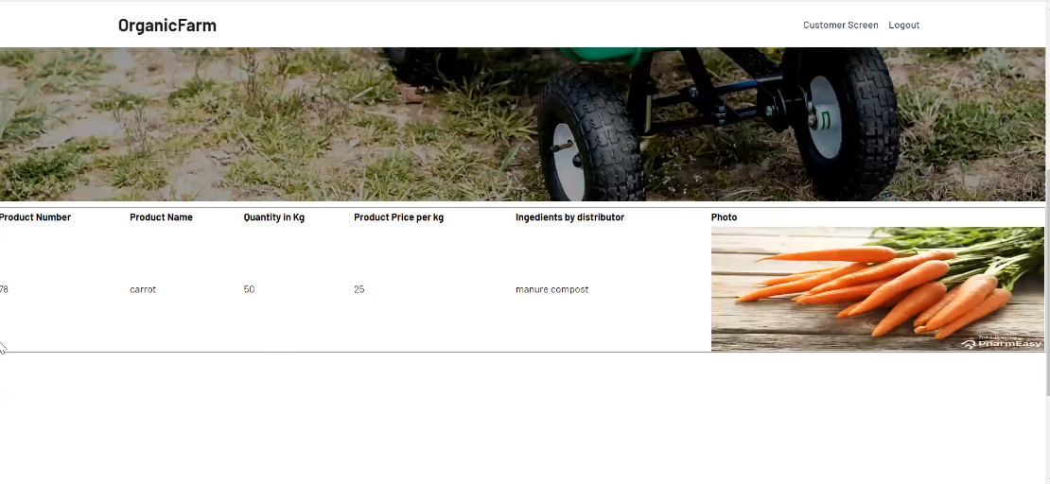

Screenshot:9.29 Customer Authenticate Scan Screen Details

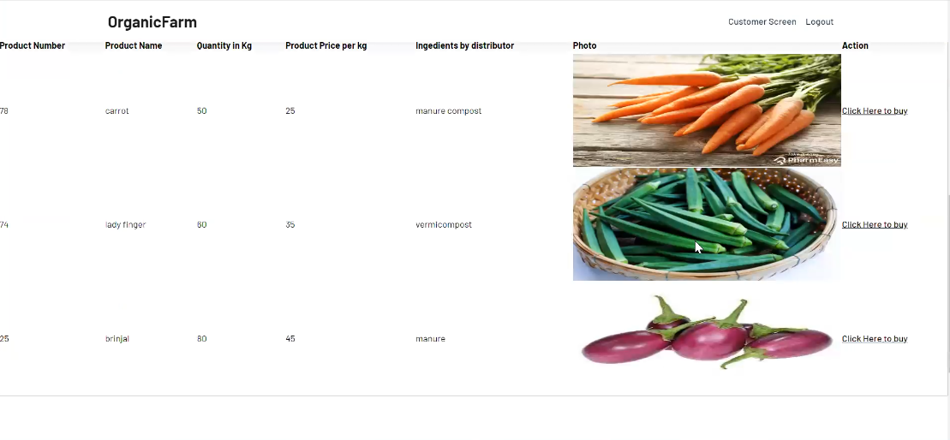 Screenshot:9.30 Customer Screen

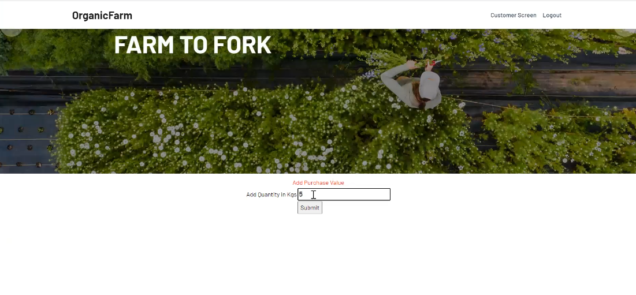

Screenshot:9.31 Customer Purchase Screen

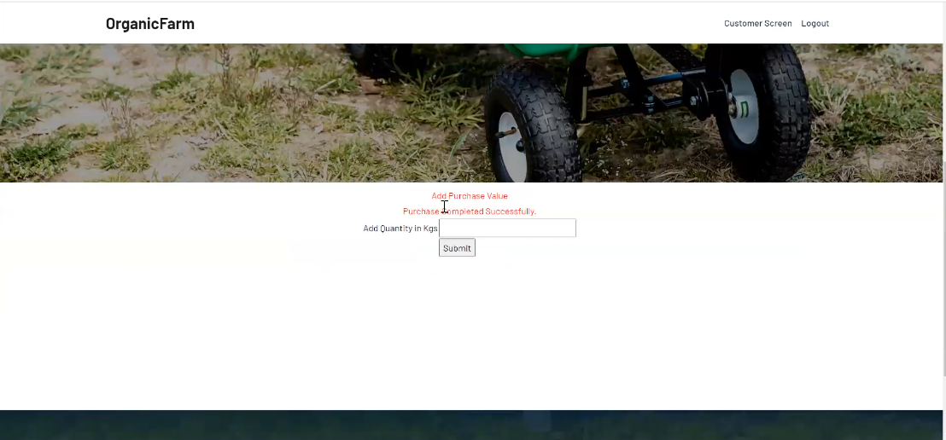 Screenshot:9.32 Customer Purchase Value Screen

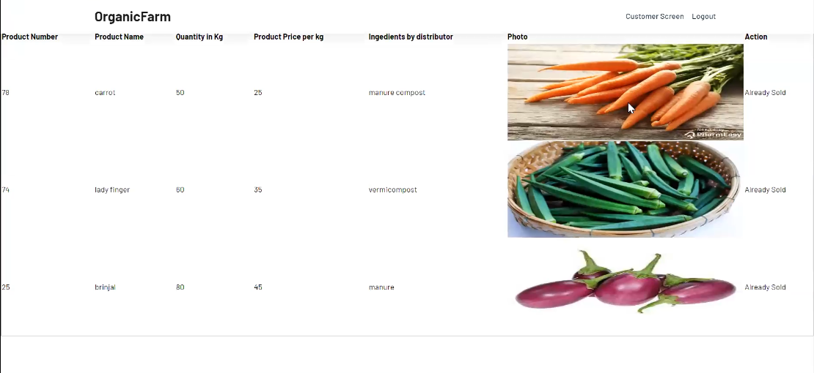 Screenshot:9.33 Customer Purchased Products Successfully

**Ganache Screen Shots:**

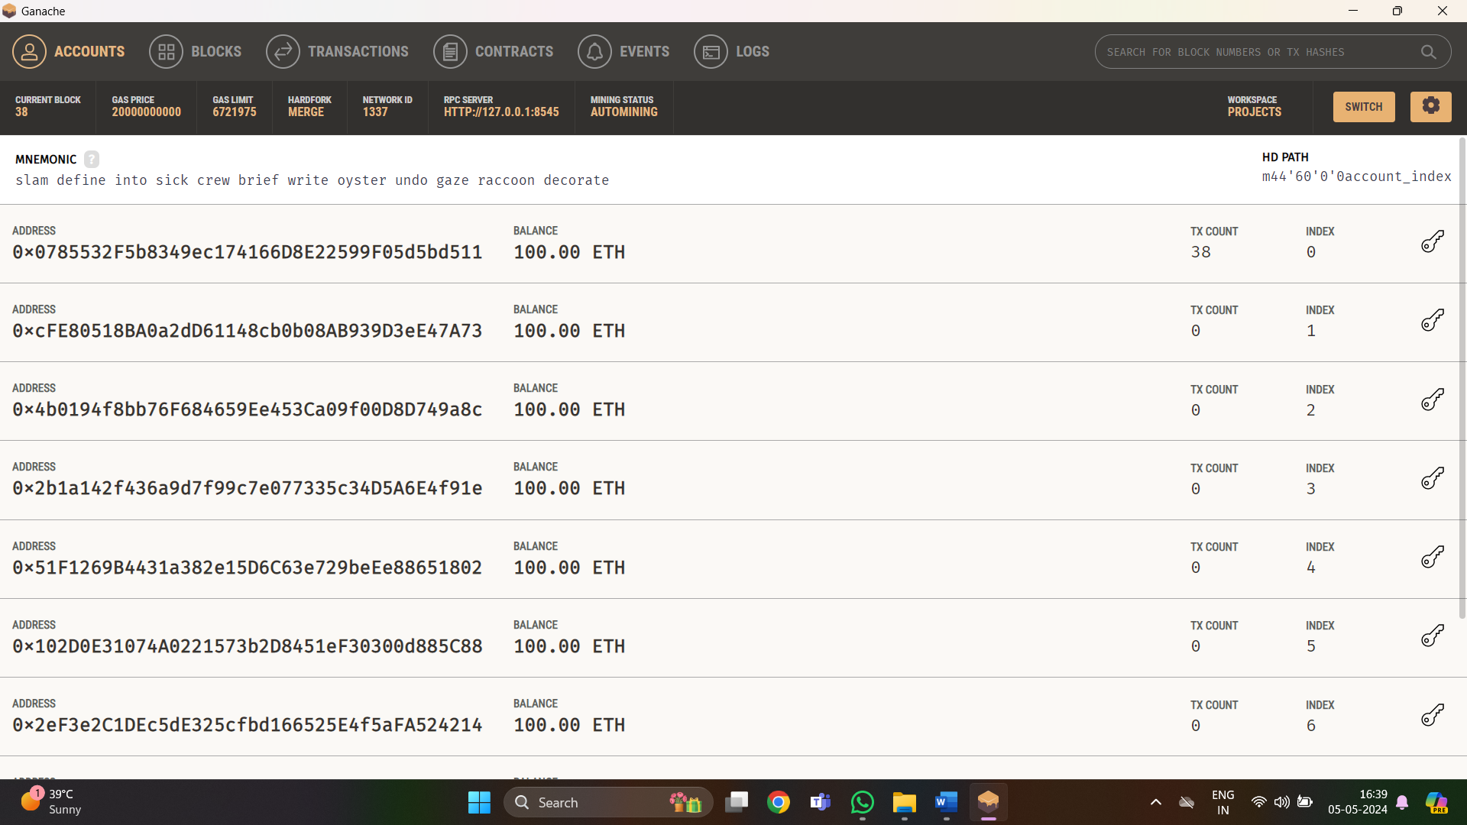

Screenshot:9.34 Ganache Dash Board

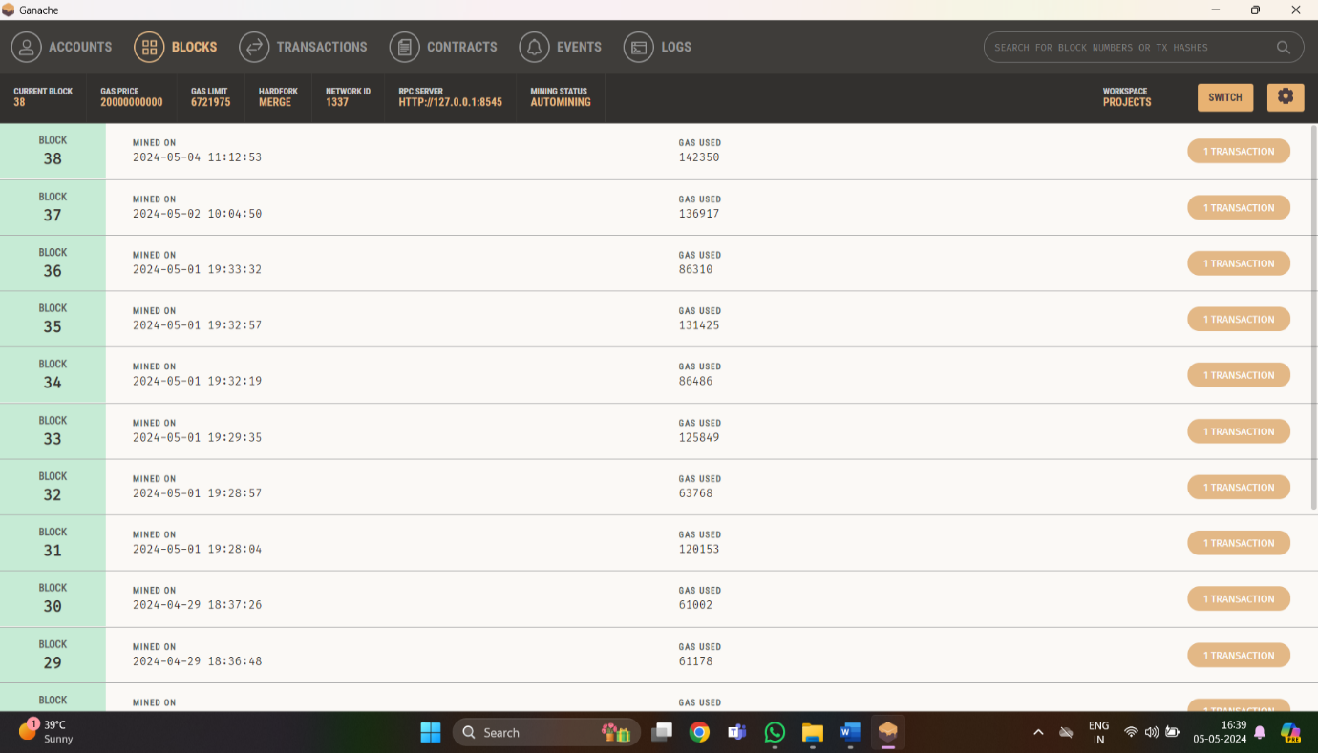

Screenshot:9.35 Ganache Blocks Screen

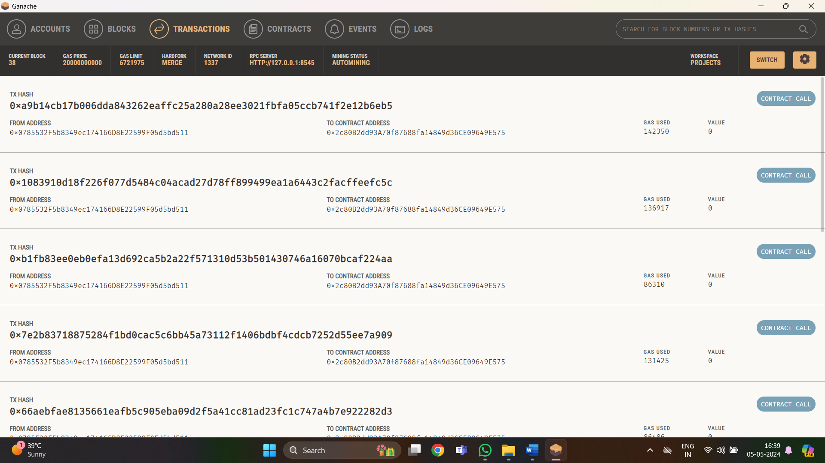

Screenshot:9.36 Transactions In Ganache

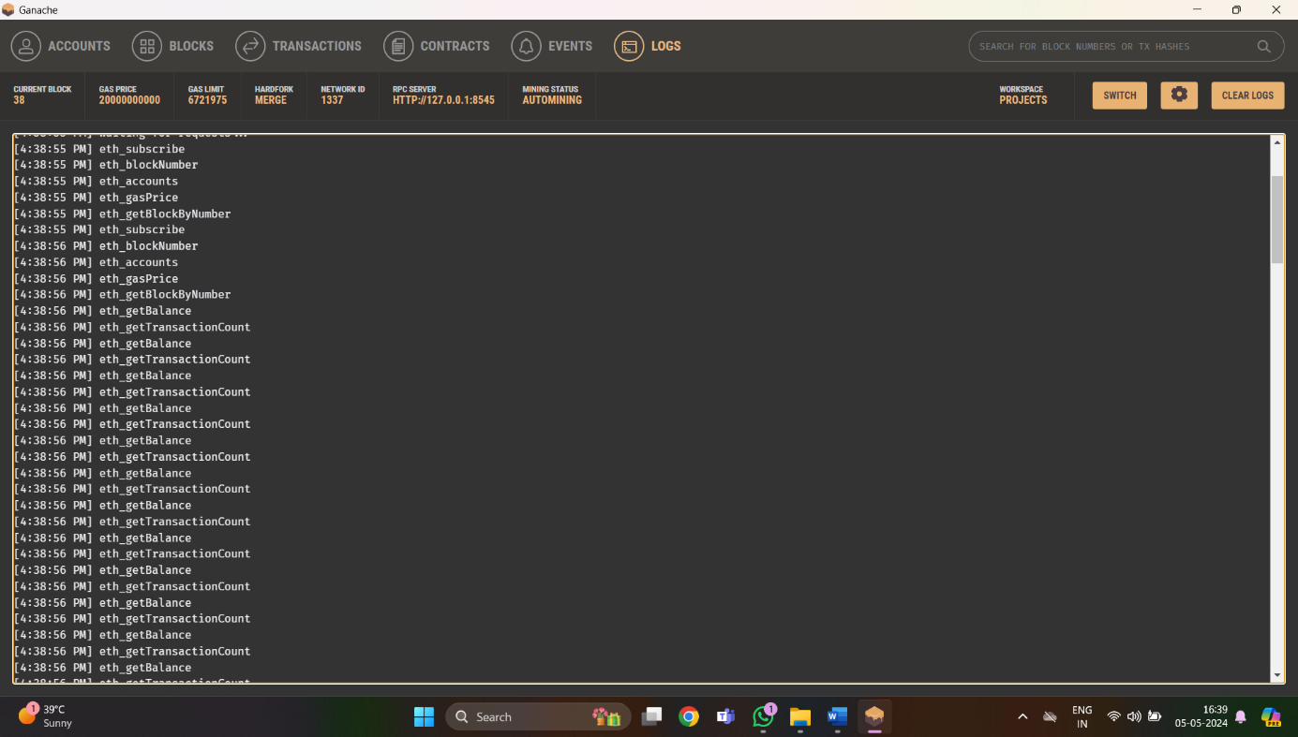

Screenshot:9.37 Logs In Ganache

**MetaMask:**

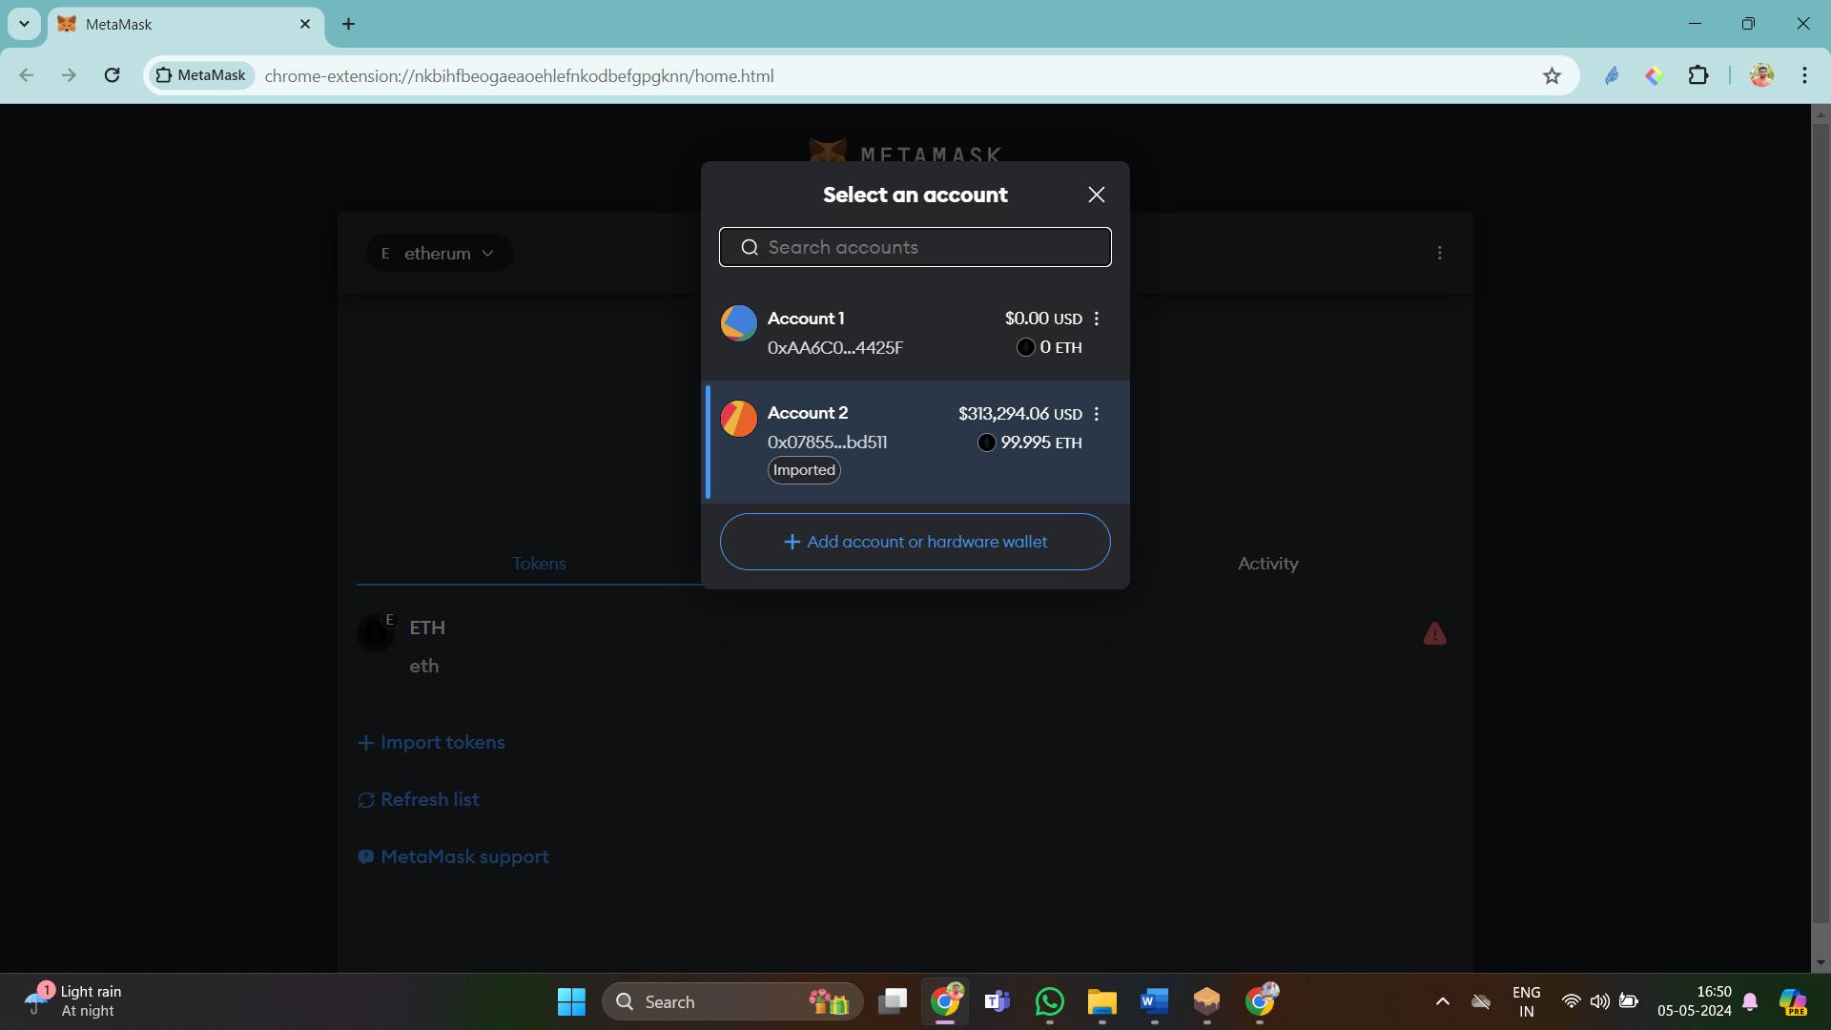

Screenshot:9.38 MetaMask Dash Board

**10. CONCLUSION**

* The primary goal is to establish a decentralized system utilizing blockchain technology within the organic food supply chain. This system aims to ensure both the quality of products and the authenticity of their sources. By leveraging blockchain's decentralized nature, the project strives to create a transparent and reliable method for tracking organic food from its origin to the consumer's possession.
* The integration of blockchain technology aims to fortify the security of data within the supply chain. By utilizing the inherent characteristics of blockchain—immutability and decentralization—the project reduces the risk of data tampering and fraudulent activities.
* Smart contracts play a pivotal role in bolstering the security and authenticity of the supply chain data within the blockchain system. These contracts automate and execute predefined rules, further mitigating risks associated with tampering and ensuring the integrity of transactions and records.
* To assure customers of the authenticity and quality of products, the project provides quality assurance certificates. These certificates serve as a guarantee, instilling confidence in customers regarding the organic nature and quality of the goods they purchase.
* Leveraging the capabilities of the blockchain-based system, participants in the supply chain can track the entire journey of products. This includes tracing the source of raw materials, validating production processes, and ensuring the authenticity of the final products. Transparency across the supply chain is enhanced, fostering trust among stakeholders.
* Overall, the project serves as a demonstration of the advantages of blockchain technology in the organic food supply chain. It provides a secure, transparent, and immutable platform that benefits all stakeholders involved, ensuring trust, reliability, and authenticity throughout the supply Chain.

**11. BIBLIOGRAPHY**

[1] Biswas M, Mahi M, Nayeen J, Hossen R, Acharjee UK, Md W. BUVOTS: A Blockchain based Unmanipulated Voting Scheme. Rakib and Acharjee, Uzzal Kumar and Md, Whaiduzzaman, BUVOTS: A Blockchain Based Unmanipulated Voting Scheme (November 23, 2020). 2020 Nov 23.

[2] Mukherjee PP, Boshra AA, Ashraf MM, Biswas M. A Hyper-ledger Fabric Framework as a Service for Improved Quality E-voting System. In2020 IEEE Region 10 Symposium (TENSYMP) 2020 Jun 5 (pp. 394- 397). IEEE.

[3] Al-Amin S, Sharkar SR, Kaiser MS, Biswas M. Towards a BlockchainBased Supply Chain Management for E-Agro Business System. InProceedings of International Conference on Trends in Computational and Cognitive Engineering 2021 (pp. 329-339). Springer, Singapore.

[4] Akib AA, Ferdous MF, Biswas M, Khondokar HM. Artificial Intelligence Humanoid BONGO Robot in Bangladesh. In2019 1st International Conference on Advances in Science, Engineering and Robotics Technology (ICASERT) 2019 May 3 (pp. 1-6). IEEE.

[5] Hossain, M.P., Khaled, M., Saju, S.A., Roy, S., Biswas, M.: Vehicle registra-tion and information management using blockchain based distributed ledger frombangladesh perspective. In: 2020 IEEE Region 10 Symposium (TENSYMP). IEEE

[6] Datta P, Bhowmik A, Shome A, Biswas M. A Secured Smart National Identity Card Management Design using Blockchain. In2020 2nd International Conference on Advanced Information and Communication Technology (ICAICT) 2020 Nov 28 (pp. 291-296). IEEE.

[7] Mahi MJ, Hossain KM, Biswas M, Whaiduzzaman M. SENTRAC: A Novel Real Time Sentiment Analysis Approach Through Twitter Cloud Environment. InAdvances in Electrical and Computer Technologies 2020 (pp. 21-32). Springer, Singapore.

[8] Ahamed, S., Siddika, M., Islam, S., Anika, S., Anjum, A. and Biswas, M., 2021. BPS: Blockchain Based Decentralized Secure and Versatile Light Payment System. Asian Journal of Research in Computer Science, pp.12-20.